Department of Pharmacology and Toxicology
The department of Pharmacology and Toxicology, University of Baghdad established in 1971in order to offer educational programs that cover scientific fields include: Pharmacology, Toxicology and Physiology. These courses required as a part of the requirement for the Bachelor Degree (B.Sc.) in Pharmacy. In addition to the undergraduate courses, the department also offer graduate study courses that include: Diploma in Toxicology, Master of Science in Pharmacology and Toxicology (M.Sc.), and Doctor of Philosophy in Pharmacology and Toxicology (Ph.D.).

Vision
The department aims to be one of the leading programs in the country and region regarding Pharmacology and Toxicology education and research.

Mission
1- Graduating highly qualified ethical pharmacists.
2. Building the leadership qualities in graduates through teaching how to lead, problem solving, team work, quality considerations, and professionalism at work.
3. instilling in graduates the spirit and commitment for acquiring knowledge and community service.
4. Contributing ideas of projects and carrying out research for the benefit and development of the community.
5. Nurturing and care of outstanding students and encouraging them to use their skills.
6. Student counseling, guidance and strengthening of citizenship spirit.
7. Providing good working environment for students, faculty, and other personnel with emphasis on high academic, professional and ethical standards within the university campus. Freedom of opinions and respect of others opinions and encouragement in exchanging knowledge.

Department Educational Objectives (DEO)
Since its establishment, the department worked hardly and continuously based on his noble mission in the society to achieve a number of strategically goals and objectives, the most important are:
- Graduate pharmacists to serve society in the health sector like hospitals and laboratories, industrial sector.
- Improving pharmacology and toxicology educational program of the comparable colleges in the country.
- Leading and improving vital applied scientific research in pharmacology and toxicology that could find suitable markets in the country and abroad.
- Cooperate with other health institutions to conduct research, and to improve pharmacology education.
- Support other colleges of Pharmacy in the country with qualified faculties through the postgraduate programs.
- Optimum use of resources and potentials of the department.

Consistence of the Program Educational Objectives with the Mission
The Pharmacology and Toxicology Department DEOs are aligned well, closely linked to, and consistent with the department’s mission. The first one of the objectives (DEO-1) provides the first step towards a career of achievement and service. The needed background of knowledge and skills are acquired to achieve this objective. Students acquire quality education through several avenues, including knowledge, skills and values as reflected in DEO-1. The professional and ethical issues are also preserved in (DEO-1). DEOs 2 -6 ensure the qualities for self-development and professional growth and improvement of the faculty, administrative and technical staff. The Department DEOs are closely linked to, and consistent with, the University of Baghdad and College of pharmacy education missions. The University and College missions are directly served by the first, third and sixth Department PEOs.

DEOs Review
The process of review and evaluation of the Pharmacology and Toxicology department is done through the following assessment channels:
1. Alumni survey.
2. Employer’s survey.
3. Faculty discussion.
4. Student’s survey.
5. Related institutions consultations (e.g. hospitals, factories, research centers).

Program Outcomes
The outcomes of Pharmacology and Toxicology program are:
a. An ability to apply knowledge of physiology, Pharmacology, and Toxicology.
b. An ability to design and conduct researches, as well as to analyze and interpret data.
c. An ability to design a formulation to meet desired needs.
d. An ability to function on multi-disciplinary teams.
e. An ability to identify, formulates, and solves pharmacological problems.
f. An understanding of professional and ethical responsibility.
g. An ability to communicate effectively.
h. The broad education necessary to understand the impact of pharmacology in a global and societal context.
i. A recognition of the need for, and an ability to engage in life-long learning.
j. An ability to recognize of drug interactions and drug misuse.
k. An ability to use the techniques, skills, and modern pharmaceutical tools necessary for pharmacy practice
The program outcomes are closely linked to the program educational objectives. The relationship illustrating the program outcomes serving each objective is mapped in Table (1).

Table (1):Relationship between program outcome and department educational objectives.
DEOs | Program Outcome
1-Graduate pharmacists to serve society in the health sector like hospitals and laboratories, industrial sector | a,b,c,d,e,f,g,h,j,k
2- Improving pharmacology and toxicology educational program of the comparable colleges in the country | b,d,e,f,g,h,i,k
3- Leading and improving vital applied scientific research in pharmacology and toxicology that could find suitable markets in the country and abroad. | a,b,c,d,e,f,g,h,i,j,k
4- Cooperate with other health institutions to conduct research, and to improve pharmacology education | a,b,c,d,e,f,g,h,I,i,k
5- Support other colleges of Pharmacy in the country with qualified faculties through the postgraduate programs | a,b,c,d,e,f,g,h,i,j,k
6-Optimum use of resources and potentials of the department | a,b,c,d,g,i,k

Continuous Improvement
The most important responsibilities and tasks performed in the department for the purpose of continuous improvement of the educational program are:
- Organize Information Used for the Program Improvement: Continuous improvement of the educational program is a continuous task that is carried out by the Department through the Scientific Committee and the specialized committees branched from it. Curriculum revisions or corrective actions proposed by either of the above committees are presented to all department faculty members in General Board meetings for discussion, review, and approval. The department faculty actively participates in board discussions leading to a finalized set of curriculum revisions and / or corrective actions.

- Actions to Improve the Program Continuous improvement is a focus of the department and is done every day as a natural part of our profession. We strive always to improve processes that are weak and fix processes that are broken. We have not set “degrees of attainment” goals for each of the outcomes. We attempt to work on every deficit we uncover in our efforts to achieve outcomes. We expect every instructor to continuously improve the performance of students in his / her subjects, whether they are currently at low or high level. The following specific actions have either been successfully implemented or are in process.
1. Comprehensive changes in curriculum in each academic year.
2. Continuous improvement of faculty through training programs.
3. Promoting a number of faculty members to higher ranks.
4. Purchasing a number of laboratory equipment and instruments.
5. Purchasing a number of books for the library of the department.
6. Increase in extra-curricular activities for students such as setting up scientific conferences and seminars.
7. Reconstruction and rehabilitation of classrooms and rooms in the department, as well as services.

Organizational Structure
The scientific, technical and administrative structure of the Department at the includes a set of integrated elements. Each one of these elements of the structure has authorities, duties and responsibilities which are specified accurately so that the department can works well and achieve the required goals through the integrity of work of these elements. The figure (1) shows the organizing structure of the department.

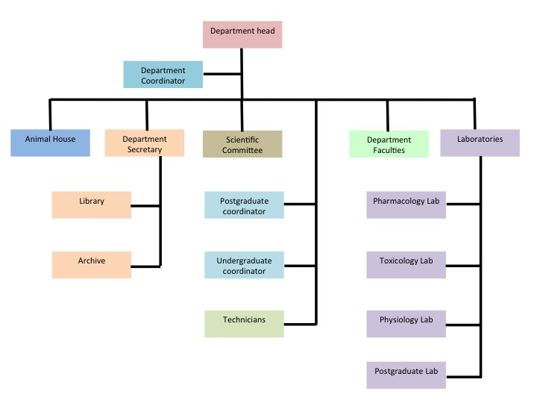

Figure 1: Organizational structure of the department.

Faculty Qualifications
This part describes the qualifications of the faculty and how they are adequate to cover all the curricular areas of the program and also meet any applicable program criteria. All are explained in Table 1-2. The department housed 12 PhD and 4 M.Sc. degrees in addition to 5 B.Sc technicians worked in the department's laboratories.

Table (2): faculty qualifications of the department
Faculty Name | Rank | Degree | Graduation from
Sajida Hussein Ismael | Professor and chair | PhD | University of Baghdad/College of Pharmacy
Nada Naji Alshawi | Professor | PhD | University of Baghdad/College of Pharmacy
Ammar Ali Albader | Lecturer | M.Sc. | University of Baghdad/College of Pharmacy
Murtadha Mutar Alshareifi | Lecturer | PhD | University of BaghdadCollege of Pharmacy
Munaf Hashem | Lecturer | PhD | University of Baghdad/College of Pharmacy
Sarmad Kadhum | Lecturer | PhD | University of Baghdad/College of Pharmacy
Ahmed Hamed | Lecturer | M.Sc. | University of Baghdad/College of Pharmacy
Shehab Hatab Mutlaq | Lecturer | M.Sc. | University of Baghdad/College of Pharmacy
Farah kais | PHD student | M.Sc. | University of Baghdad/College of Pharmacy
Hasan Alhaddad | Assist. Lecturer | M.Sc. | University of Toledo/USA
Mahmood Kahtan | Assist. Lecturer | M.Sc. | University of Coventry/ UK
Alaa radi khudiar | Assist. Lecturer | M.Sc. | University of Baghdad/College of Pharmacy
Safa Mustafa | Assist. Lecturer | M.Sc. | University of Baghdad/College of Pharmacy
Ali Jabbar | Assist. Lecturer | M.Sc. | University of Nottingham Trent/UK

Authority and Responsibility of Faculty
The head of the department is appointed by the President of the University based on the recommendation of the Dean of the College of Pharmacy. The authority of the department’s head spans in general for four conductive years. At the end of four years, the authority can be extended or another faculty member is appointed to take his/her position. The department’s head assigns the members and coordinators of the department and various committees within the department. He/she distributes the administrative tasks and academic affairs to the designated department Committee. The department’s head leads the department council meetings and represents the department at the college of pharmacy council meetings. The Head of Department shall exercise scientific, administrative and financial authorities by which he can perform his job.
The department’s full-time faculty responsibility includes teaching, research, institutional and committee services, and professional society services. Most of the department academic and the general program issues are taken care of by the relevant committees. Usually, course modification and evaluation is the main task of the scientific committee. However, a faculty member can initiate the creation of a new course. Major curriculum renovation is usually presented by the scientific committee at the department’s General Board meeting where each faculty member has the chance to interfere in the creation or modification process. The curriculum modification proposal is presented to the college of Pharmacy curriculum committee for final approval.

Laboratories
Pharmacology and Toxicology Department contains three laboratories and animal house which includes many devices and equipment used to conduct the experimental tests by undergraduate students and it is helpful to conduct the graduation projects by the fifth class students, in addition to the ability of using many of them to achieve different tests and other works to the government establishments, private sector, postgraduate students and researchers generally These laboratories are: pharmacology and toxicology lab, physiology lab, and postgraduate lab.

Courses and Credits
The department responsible for teaching the courses listed in table (3) with their names, codes, year/semester required and their hours/week for the theoretical and practical (lab) classes. The distribution of the credits of the department compared to the total credit required by the College of Pharmacy illustrated in figure (2).

Table (3): courses and credits of the department.

Uinversity of baghdad /college of pharmacy 2016-2017 (Coding Subjects in Preliminary Studies)
Code college |  |  |  | The department name | No. |  | Code |  |  |  |  |  |  |  | stage |  |  | The course name |  | No. |  |  | Code |  |  |  |  |  | Course Title
1st Semester
1003 |  |  | Pharmacology and toxicology |  |  | Pt |  |  |  | 01 |  |  |  | 1 |  |  | Medical Terminology |  | Mt |  |  |  |  | 04 |  |  |  | 104 PtMt
Code college |  |  | The department name |  |  | No. |  |  |  | Code |  |  |  | stage |  |  | The course name |  | No. |  |  |  |  | Code |  |  |  | Course Title
1st Semester
1003 |  | Pharmacology and toxicology |  |  |  |  |  | Pt |  |  | 01 |  | 2 |  |  | Physiology I |  |  |  |  |  | Ph1 |  |  | 16 |  | 216 Ptph1
2nd Semester
1003 | Pharmacology and toxicology |  |  |  |  |  |  |  | Pt |  | 01 | 2 |  |  | Physiology II |  |  |  |  |  | Ph2 |  |  |  | 22 | 222 PtPh2

Code college |  |  |  |  | The department name | No. |  |  |  |  | Code |  | stage | The course name |  |  | No. | Code | Course Title
2nd Semester
1003 |  |  |  | Pharmacology and toxicology |  |  |  |  | Pt |  |  | 01 |  |  | 3 | Pharmacology I |  |  |  | Pc1 | 30 | 330 PtPc1
Code college |  |  |  | The department name |  |  |  |  | No. |  |  | Code |  |  | stage | The course name |  |  |  | No. | Code | Course Title
1st Semester
1003 |  |  | Pharmacology and toxicology |  |  |  |  | Pt |  |  |  | 01 |  |  | 4 | Pharmacology II |  |  |  | Pc2 | 35 | 435 PtPc2
2nd Semester
1003 |  | Pharmacology and toxicology |  |  |  |  |  |  |  | Pt |  | 01 |  |  | 4 | Pharmacology III |  |  |  | Pc3 | 40 | 440 PtPc3
1003 |  | Pharmacology and toxicology |  |  |  |  |  |  |  | Pt |  | 01 |  |  | 4 | General Toxicology |  |  |  | Gt | 43 | 443 PtGt
Code college |  | The department name |  |  |  |  |  |  |  | No. |  | Code |  |  | stage | The course name |  |  |  | No. | Code | Course Title
1st Semester
1003 | Pharmacology and toxicology |  |  |  |  |  | Pt |  |  |  |  | 01 |  |  | 5 | Clinical Toxicology |  |  |  | Ct | 50 | 550 PtCt
1003 | For all departments |  |  |  |  |  |  |  |  |  |  |  |  |  | 5 | Project** |  |  |  | Pr | 51 | 551 Pr

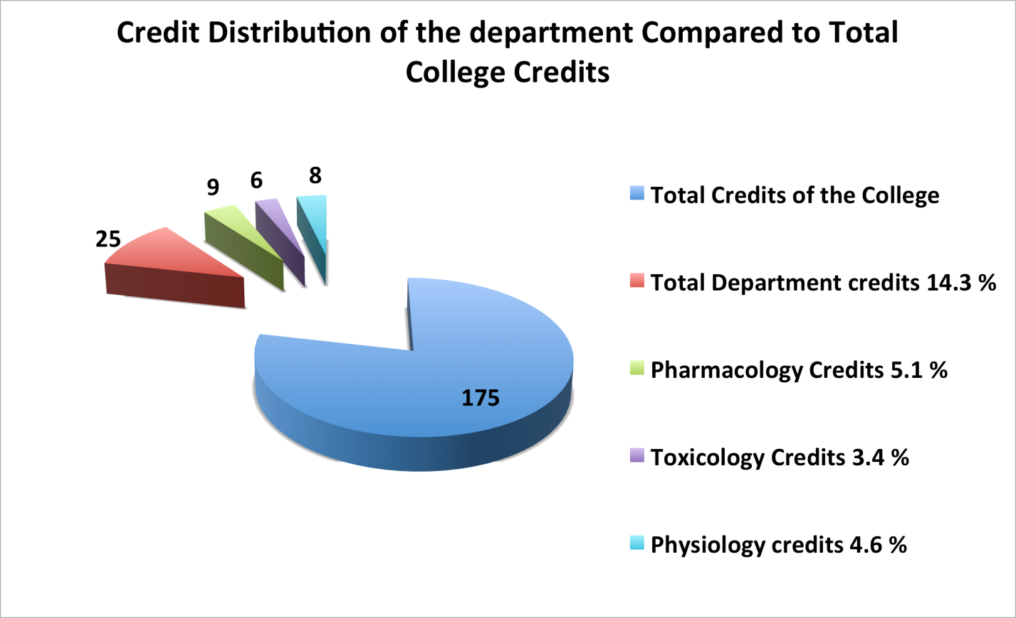
Figure 2: Department’s Credit distribution compared to the total credits of the College of Pharmacy.

SWOT Analysis for pharmacology and toxicology Program
SWOT analysis it is a strategic planning method used to evaluate the Strengths, Weaknesses, Opportunities, and Threats involved in any organization. It involves specifying the objectives of the project and identifying the internal and external factors that are favorable and unfavorable to achieving those objectives:
A closer examination of the SWOT analysis reveals that college strategic plan, including pharmacology and toxicology Program, should focus on the improvements that are related to students, teaching methods, faculty, and facilities. Therefore, the following strategic objectives have been developed to address the weaknesses and threats related to various aspects of those issues…
1. Recruit, nurture and retain outstanding students.
2. Promote a strong sense of community and collegiality among the students, faculty, staff and alumni.
3. Improve teaching and learning through continuous assessment.
4. Promote research and consultation that address the immediate and long-term needs of the society.
SWOT analysis for the students,curriculum, faculty and research of the department summarize in the following table (4-7).

Table (4) shows the SWOT analysis for the students.
Strengths (internal) | Weaknesses (internal)
1- Provides a learning environment which enables students to obtain strong foundation of pharmacology and toxicology knowledge, laboratory skills, and problem solving skills.  1. A very good experience in academic education for the faculty members.  2. Sufficient number of faculty members.  3. The long and rich history, as well as the good reputation of the department.  4. Good relationships between employees and students of the department.  5- Applying the modern methods of teaching  6- Increasing and encouraging sports activities, which empower students to practice sports and training. | Weakness in the students' English language level.
OPPORTINITIES (EXTERNAL) | THREATS (EXTERNAL)
1. New trends in multi-disciplinary professional education and new teaching methods.  2. High proportion of demand for higher education in Iraq.  3. The presence of government financial support for official universities.  4. Developing good relationships with alumni. | 1- Emerging local and regional private colleges.  2- The increasing number of students entering the faculty, increasing pressure on the available potentials and resources, negatively affecting student services.

Table (5) shows the SWOT analysis for the curriculum of the department.
Strengths (internal) | Weaknesses (internal)
1. Designed to meet both local needs and international standards.  2. Strong pharmacology and toxicology science components.  3. Availability of a good variety of general education subjects.  4. A well-structured laboratory experience.  5. A strong professional component.  6. There is constancy throughout the years of study in the process of “pumping” subjects from the three specialties of the department, so that there is no gap in the five years of study .  7. Acceptable equipped laboratory.  8- concentration of curriculum to teach students to work in team. | 1. Lack of attention to give courses in English, especially in the scientific discussion within the classroom.  2. The style of the given curriculum tends to make the student recipients and not learner.
OPPORTINITIES (EXTERNAL) | THREATS (EXTERNAL)
1. New trends in multi-disciplinary professional education and new teaching methods.  2. - Possibility of re-designing curriculum to allow multi-disciplinary teaching and learning | 1- Quality of incoming students (language, analytical thinking, motivation).

Table (6) shows the SWOT analysis for the faculty of the department.
strengths (internal) | weaknesses (internal)
1. Good social relationships between faculty members of the department.  2- Meeting of staff with Head of Department, which will aid personal and departmental planning and development  3. Achievements by department members  are adequately celebrated.  4. A very good experience in academic education for a good number of the faculty members. .  5. Excellent and versatile academic backgrounds.  6. A very well specifically defined responsibilities and authorities for all faculty members.  7. Large and continuous desire for development, and strong motivation for service for most faculty members of the department.  8.Increase the participation in scientific conferences, workshops and training courses.  9. Good relationships between faculty members and students of the department. | 1- Poor relationship with international research centers.  1-Lack of trained technicians for operation and maintenance of the advanced scientific equipment.
opportunities (external) | threats (external
1-Available faculty development opportunities.  2- Possibility of utilizing local talent for teaching and research.  . | 1- Private universities can attract the highly qualified members of the staff.  2- Reduced financial support for professor as a scientific researcher

Table (7): shows the SWOT analysis for the research of the department.
STRENGTHS (INTERNAL) | WEAKNESSES (INTERNAL)
1- All teaching staff take part in the research process.  2- Availability of access to scientific journals.  3-Motivation of the staff members to share in scientific conferences, symposiums and workshops.  4- Implementation of the researcher position and recruitment of researchers in some departments. | 1- Lag in the delivery of the research requirements as chemicals, glass wares and instruments, secondary to routine procedures.  2- Lack of some advanced instrument that required for some researches.
opportinities (external) | threats (external
.1. Available programs to make communication with the external stakeholders as hospitalsand drug companies.  2. Establishment of external scholarships. | 1. Lack in the transfer of the researches to the application fields.  2. External research centers in other universities can attract outstanding researchers.

Dr.Sajida Hussein Ismael
Head of Pharmacology and Toxicology
College of Pharmacy/Baghdad University
10/10/2017

