**University of Baghdad;**



**College of Pharmacy;**

**Department of Pharmaceutical Chemistry.**

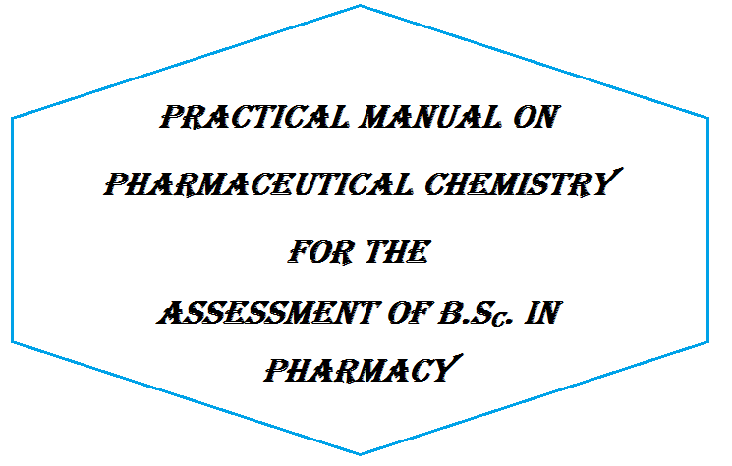

**By**



**Qualitative Analysis of Organic Compounds**

Qualitative analysis of organic compounds helps identify and characterize unknown organic compounds. Many organic compounds are usually a component of a mixture of several compounds that might be considered as impurities.

These impurities may be side products resulted during the preparation of the organic compound or may be decomposition products of the original pure organic compound and this occurs during storage under unsuitable conditions. Also some compounds may be obtained and stored pure because of their high degree of stability.

In most cases a good separation and purification should precede qualitative analysis of organic compounds so that identification will be successful.

The qualitative analysis of any organic compound should follow these steps:

1. Physical properties studying:

* State of the organic compound (solid, liquid, gas)
* Determination of the melting point or boiling point.
* Color, taste, and odor of the compound.
* Determination of the solubility group .

2. Chemical properties studying:

* Effect of the compound or its solution on litmus paper.
* Determination of elements in the organic compound .
* Detection of the organic groups, i.e. group classification .
* Specific classification tests.
* Preparation of derivatives.

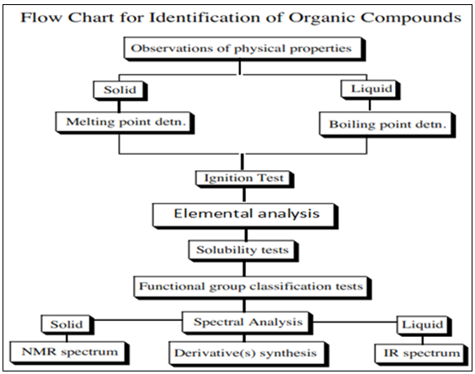

**DETERMINATION OF MELTING POINT**

The Melting Point of a solid crystalline compound is the temperature at which the solid begins to change into liquid under a pressure of one atmosphere, or it is the temperature at which there is equilibrium between liquid and solid states. If the resultant liquid is cooled, solidification will occur at the same temperature, *i.e*. themelting point and thefreezing point for a pure substance are identical.

* **AIM OF MEASURING THE MELTING POINT**

1. The Melting Point is considered as a criterion of purity of a compound.

2. The Melting Point is useful for identification of organic compounds.

* **MELTING POINT RANGE**

There is a temperature difference between the beginning of melting (T1) and the end of melting (T2) at which the entire solid converts into liquid (The Melting Point Range).

Pure organic compounds usually have sharp melting points and they melt within a range of about 0.5℃-1℃, while impure substances have no sharp melting points and melt over a range of several degrees. Some of pure organic compounds if they undergo slight decomposition before reaching the melting point The decompos products act as impurities that decrease the melting point and increase the melting point range.

* **PROCEDURE**

The method used for the determination of the melting point is called the **Capillary Tube Method**.

Few milligrams of the fine solid are placed in a thin glass capillary tube having a diameter of about 1 mm. The capillary tube is attached to a thermometer and is then placed in an oil bath. Heating is started gradually.

The range between the temperature at which the powdered solid inside the capillary tube begins to melt (T1) and the temperature at which a clear liquid is observed inside the capillary tube(T2)is recorded .This is a Melting Point Range.

* **NOTES**

1-The solid compound must be finely powdered.

2- The rate of heating should be controlled. ( be very slow near the melting).

3-point so that the melting point can be recorded accurately.he temperature of the oil bath, paraffin or glycerin, should rise very slowly. Therefore, gentle heating and continuous stirring are necessary.

4-The capillary tube containing the powdered solid substance is attached to the thermometer by a small rubber ring.

5-After completing the experiment the oil liquid must be allowed to cool before using it again.

**DETERMINATION OF BOILING POINT**

The Boiling Point of an organic liquid is the temperature at which its vapor pressure equals the atmospheric pressure over the liquid, or it is the temperature at which the vapor and liquid phases are in equilibrium at a given pressure.

* **AIM OF MEASURING THE BOILING POINT**

1. The Boiling Point is considered as a criterion of purity of a compound.

2. The Boiling Point is useful for identification of organic compounds.

Similar to the melting point the boiling point may be sharp or may vary over a temperature range. Pure liquids have sharp boiling points while mixtures show a boiling point range.

The atmospheric pressure plays an important role in determination of the boiling point correctly. Reduction of the pressure leads to a decrease or a depression in the boiling point and vice versa.

* **PROCEDURE**

1. A 5-cm capillary tube closed from one end is attached to a thermometer by a rubber ring.
2. Place them in a clean and dry test tube containing a small quantity of a liquid whose boiling point is to be measured.
3. The whole assembly is to be placed in an oil bath.
4. Start heating with continuous stirring until a rapid stream of bubbles comes out of the capillary tube (inside the liquid).
5. Remove the flame and allow the oil bath to cool so that the bubble stream will become slower and slower as the temperature drops until a point is reached at which bubbling ceases and the liquid starts to rise inside the capillary tube.
6. Record this temperature as the boiling point.

**ELEMENTAL ANALYSIS**

Elemental analysis is considered as an important step in the identification of organic compounds. The chief elements making up organic compounds are carbon, hydrogen, and oxygen. Next to them in order of importance are nitrogen, halogens (chlorine, bromine, fluorine, and iodine) and sulfur that can be detected by reaction with sodium metal.

* **SODIUM FUSION METHOD**

The halogens, nitrogen and sulphur are covalently bonded to the organic compounds. In order to detect them, the elements need to be converted into their ionic forms. This is done by fusing the organic compound with sodium metal. The ionic compounds formed during the fusion are extracted in aqueous solution and can be detected. The extract is called sodium fusion extract solution . The nitrogen is confirmed with ferrous sulphate.



* **NOTES**

Sodium element is dangerous and extreme care should be exercised when handling it since sodium element can react vigorously with water resulting in explosion.

Na + H2O NaOH

Therefore sodium element is kept dipped in liquid paraffin to prevent exposure to moisture. The paraffin should be wiped off before using the sodium. It is also advised not to touch it directly by the hands since hands are usually moist resulting in burning sensation. Note that sodium is a shiny element and when it is exposed to air and moisture it is oxidized and become non shiny.

* **PROCEDURE**

A small quantity of the unknown is placed in a clean, dry test tube together with a small piece of sodium metal. The test tube is held vertically by a clamp. The lower part of the test tube is heated gradually until the sodium melts and its vapors fill the lower part of the tube. This gradual heating is to prevent the loss of the products as vapors. Heating is then continued for additional five minutes until the bottom of test tube becomes red.

Cautiously drop the still hot test tube into a beaker containing about 20 ml of distilled water. The tube will break down and, if not, use a glass rode to break it. The resulting solution is heated almost to boiling and filtered. The filtrate, which should be colorless, is used for the specific tests.

* For liquids it is better to first melt the sodium add the liquid drop by drop.
* **CAUTIONs**:

Any unreacted sodium should be removed before breaking down the tube , to remove the excess unreacted sodium add a small quantity of alcohol (ethanol or methanol) to the test tube before breaking it with heating

Na + CH3CH2OH NaOCH2CH3

ethanol sodium ethoxide

1. **DETECTION OF NITROGEN**

To 3 ml of the filtrate add 4 drops (0.2 gm) of ferrous sulfate solution. Check the basicity of the solution and make it basic by the addition of enough sodium or potassium hydroxide solution (10%). Heat for boiling (30 sec.). Now add drops of dilute sulfuric acid enough to make the solution acidic. A Prussian blue precipitate indicates a positive test of nitrogen.



Fe(CN)2 + 4NaCN Na4Fe(CN)6 sodium ferrocyanide

In alkaline solutions insoluble hydroxides of ferrous and ferric ions are formed since ferrous ions are oxidized into ferric ions by the action of air. These must be dissolved by the addition of dilute sulfuric acid to get soluble reactive ions.



Ferric ion will react with the ferrocyanide ion to produce the Prussian blue precipitate, ferric ferrocyanide.



In the acidification step hydrochloric acid is not used because this results in the formation of yellow ferric chloride that converts the color of the precipitate from blue to green. If the organic compound contains sulfur in addition to nitrogen, excess ferrous sulfate must be added since it reacts with the sulfide ion producing ferrous sulfide. However, this product does not affect the detection of nitrogen.

1. **DETECTION OF SULFUR**

Acidify 2 ml of the filtrate with dilute acetic acid, add 5 drops of lead acetate solution. A black precipitate of lead acetate indicates the presence of sulfur.



Reasons for the addition of acetic acid

1. To make the medium acidic since in basic pH the addition of lead acetate results in the formation of a greenish precipitate of lead hydroxide.



2. To produce hydrogen sulfide gas (characteristic odor) that reacts with lead acetate to form lead sulfide as a black precipitate.

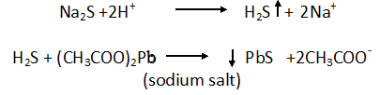

Acetic acid is used in the acidification not other acids (sulfuric, hydrochloric, and nitric) since they give insoluble white precipitate by reaction with lead acetate.

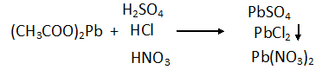

1. **DETECTION OF HALOGENS**

In case of presence of nitrogen and sulfur in the compound acidify 3 ml of the filtrate with dilute nitric acid (add drop by drop until the solution becomes acidic). Boil for 5 minutes and then add drops of silver nitrate.

White or yellow precipitate indicates the presence of halogens.

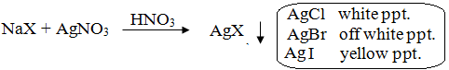

Boiling for 5 minutes is done to remove nitrogen and sulfur present in the filtrate as hydrogen cyanide and hydrogen sulfide gases.

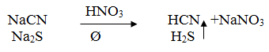

If these two are not removed from the solution they will react with silver nitrate to give black precipitate with sulfur and white precipitate with nitrogen, thus misleading the results and making the detection of halogens difficult.

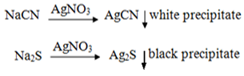

Nitric acid is useful also in forcing the reaction towards the products since it contains the common ion, NO3-.

**The separation and purification of organic compounds**

The separation and purification of organic compounds is important way to get pure organic compounds. Products of organic reactions are seldom pure products as a result of side reactions. Pure compounds are also subject to partial decom-position on standing for some time or on exposure to light, air, heat, moisture, etc. (for example acetyl salicylic acid, commonly called aspirin, decomposes to salicylic acid). Therefore, the process of separation and purification of organic compounds becomes an important technique to get pure compounds.

Generally, organic compounds are separated and purified by the following methods:

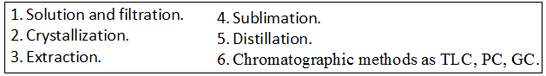

1. **SOLUTION AND FILTRATION**

When a solid or liquid dissolve, the structural units (ions or molecules) become separated from each other and the solvent molecules occupy the space between them. The solubility of organic compounds can be divided into two major types;

1. Solubility in which the chemical reaction is the driving force, for example acid-

Base reactions.

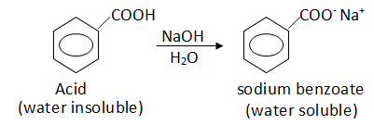

2. Solubility in which only simple miscibility is involved, for example ethyl ether in carbon tetrachloride.

The first type is used to identify the functional groups involved in the compound, while the second type is used to determine solvents for recrystallization and chemical reactions.

The factors that affect solubility are:

1. Polarity Effect. 2. The Dielectric Constant.

The filtration is an important procedure after completing the reaction either to separate the solid product (precipitate) or to get rid of insoluble impurities or reactant materials. The desired soluble compound is recovered from the filtrate by evaporating the solvent.

The liquid is poured into a filter paper fitted in a funnel and either the precipitate is collected or the filtrate that contains the desired soluble compound is collected. In this method we take the advantage that one compound in the mixture is readily soluble in a given solvent whereas the remainder of the mixture may be relatively insoluble

**PROCEDURE**

An impure mixture containing about 0.5 gm of benzoic acid and 0.5 gm of sugar (glucose) is to be dissolved in about 10 ml of distilled water. The sugar will dissolve in water while benzoic acid remains precipitated. Then perform filtration, by which the benzoic acid remains as the precipitate on the filter paper while the sugar goes with the filtrate as a solution. The sugar can be recovered from the filtrate by evaporating the solvent (water).

To test that the precipitate (on the filter paper) is benzoic acid, sodium bicarbonate solution is to be added on this precipitate. The benzoic acid will be dissolved due to the formation of soluble sodium benzoate and bubbles of the evolved CO2 gas .

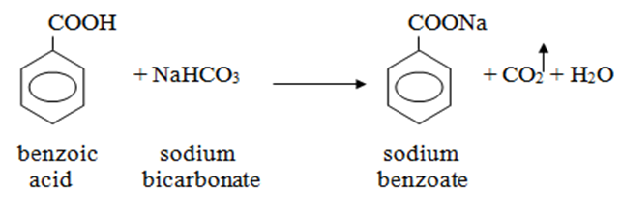

1. **RECRYSTALLIZATION**

Solid organic compounds when isolated from organic reactions are usually impure; they are usually contaminated with small amounts of other compounds that are produced along with the desired compound. The purification of impure crystalline compounds is usually done by recrystallization from a suitable solvent or a mixture of solvents.

The purification of solids by crystallization is based upon differences The method of recrystallization simply involves the preparation of a saturated solution of the compound to be purified in a small volume of the desired solvent (enough to dissolve the compound) at elevated temperatures (at or near the boiling point of the solvent). Charcoal may be used when the compound is contaminated with colored impurities.

Filtration of the hot solution is then done to separate the insoluble materials or impurities. The hot solution will then be allowed to cool up so that the dissolved compound will crystallize out. After that the crystals are separated from the remaining supernatant liquid (mother liquor) by means of filtration.

This collected crystalline solid compound is dried and is then tested for purity usually by melting point determination, spectroscopic methods, or TLC.in their solubility in a given solvent or a mixture of solvents.

* CHOOSING A SOLVENT FOR RECRYSTALLIZATION

The proper choice of a solvent is an important part of the art of crystallization. The ideal solvent should:

1. Chemically inert toward the solute.
2. Dissolve the solute readily at its boiling point but sparingly at low or room temperatures (0 – 25 ℃).
3. Dissolve impurities either very easily or not at all.
4. Inflammable, low cost, and low toxicity.

Practically, to choose a good solvent take about 0.1 gm of the compound to be purified (a pure sample) and try to dissolve it in 1 ml of the solvent: if it dissolves in the cold solvent, the solvent will not be good for recrystallization; if it dissolves in the solvent with heating, the solvent will be good for recrystallization; if it does not dissolve in the solvent even with heating, the solvent will not be good for recrystallization. Solvents extensively used for recrystallization include water, ethanol, chloroform, ether, acetone, and benzene.

* DECOLORIZING CHARCOAL

Frequently samples to be purified may contain soluble colored impurities that may cause the solution and the crystals to be colored when they should be colorless; they dissolve in the boiling solvent and are adsorbed on the crystals produced upon cooling. These impurities can be removed by treating the colored sample with decolorizing (activated) charcoal that is composed of fine carbon particles with a large active surface on which the colored impurities will be adsorbed.

Charcoal is added to the hot solution before boiling and the solution is kept hot at or near the boiling point for about 3 – 5 minutes with shaking to wet the charcoal. The solution is then filtered through a fluted filter paper. No more charcoal than actually needed should be used because any excess amount will cause the desired compound to be adsorbed on the charcoal.

Charcoal is not added at the boiling point of the solvent because its particles function as thousands of boiling chips causing the solution to boil over and foam.

Charcoal is not used in the recrystallization of phenolic compounds (Ar – OH) because it contains ferric ions that, on heating the solution for some time, can react with the phenolic hydroxyls forming red colored complexes, thus impairing the purification process.

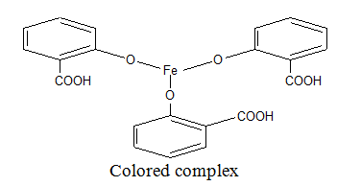

* RECRYSTALLIZATION USING MIXED SOLVENTS

This is applied when our compound is readily soluble in a solvent at room temperature, and at the same time is not soluble in another solvent. The two solvents must be completely miscible with each other such as alcohol and water, ether and pentane, and glacial acetic acid and water.

So the compound is dissolved in the solvent that it is soluble in, charcoal is used if required, and the solution is filtered to get rid of the insoluble impurities. Then the other solvent (in which the compound is insoluble) is added to the filtrate gradually until turbidity appears. The mixture is then left aside to facilitate crystallization.

PROCEDURE

Take an unknown weight of impure acetanilide and start dissolving it in a small volume of water with heating until the entire sample dissolves. Remove the solution from the Bunsen burner and leave it aside for a minute to cool. Then add a small quantity of charcoal and resume heating again with stirring for 3 – 5 minutes. Filter the mixture while being hot. Leave the filtrate to cool at room temperature to induce crystallization. Observe the produced crystals.



* NOTES If crystallization does not take place :
* Scratch the sides or the bottom of the container below the surface of the solution with a glass rod
* Add a small crystal of the pure compound
* Evaporate some of solvent to induce the crystallization process.
* The funnel, filter paper, and the container of the solution should be kept hot throughout the filtration process to prevent the deposition of the crystals on the filter paper or on the neck of funnel.So, it is recommended to wash the filter paper after filtration process with a small amount of the hot solvent.
* Use a minimum volume of the solvent to prevent the loss of the compound because large volumes of it will keep most of the compound dissolved in it.
* Drying of the purified substance can be achieved by air drying, oven drying, freeze drying, or using a desecrator containing a drying agent as anhydrous calcium chloride.

1. **EXTRACTION**

It is a method of separation and purification of organic compounds that depends on the ability of the compound to dissolve in two immiscible solvents, e.g. water and chloroform. Immiscible solvents are mixtures of liquids that are insoluble in each other. Such solvents will form two layers; the upper layer is for the liquid with the lower density and the lower layer is for the liquid with the higher density.

The process of extraction with immiscible solvents is generally employed for

* The isolation of dissolved compounds from solutions.
* Isolation of solid compounds from mixtures.
* Removal of undesirable impurities from mixtures (washing).

Water is usually one of the solvents used in an extraction process, and the other solvent is usually an organic liquid of a non-polar (nonionic) character. The organic or non-polar liquid may have a slight polar property as is indicated by its solubility in water. Ether, one of the most important organic solvents, is used extensively as an extracting solvent. It is very slightly soluble in water, and its efficiency in use can be improved by the addition of a small amount of an ionizable salt, such as sodium chloride or potassium carbonate, to the water layer.

This leads to an increase in the polar property of this solution that result in a decrease in the solubility of a non-polar compound. Therefore, ethanol, which is completely miscible with water, becomes an immiscible liquid with respect to the water layer when the water is saturated with a salt such as sodium chloride. This is known as the “salting-out” process. It is possible, to separate fractions from a mixture that contains small quantities of several organic compounds through:

1. Adjustment of the pH. b. Selection of a solvent.

c. Addition of another solute that can alter the solubility of one or more compounds (salting-out).

* CHOOSING A SOLVENT FOR EXTRACTION

A good solvent for extraction should:

1. Readily dissolve the substance to be extracted.
2. Have a low boiling point so that it can be readily removed.
3. Not react with the solute or the other solvent.
4. Show little or no water solubility (immiscible with water).
5. Inexpensive , Inflammable and not toxic.

No solvent meets all these criteria. For example, ether is probably the most common solvent used for extraction but it is flammable. However, ether has :

1. a high solvating power for hydrocarbons and oxygen containing compounds.
2. highly volatile having a boiling point of 34.6℃ so that it can be easily removed.
3. Is very slightly soluble in water.

PROCEDURE

1. Put an unknown weight of salicylic acid in a separatory funnel, and then add 25 ml of chloroform and 25 ml of distilled water.Shake gently for 15 – 20 minutes until no further pressure is released from the funnel stem.
2. Leave the funnel on an iron ring for about 5 – 10 minutes for complete separation of the two layers. The stopper must be removed.
3. Separate the lower chloroform layer slowly through the funnel stem until the aqueous layer enters the hole of the stopcock.
4. Pour the upper aqueous layer through the neck of the separatory funnel.  
   To recognize which layer is the aqueous layer and which is the organic layer, mix about 3 ml of any layer with an equal volume of water in a test tube and observe the result. If there are two layers, then that layer is the organic layer; if there is one layer means this is the aqueous layer. Take organic layer and dry it.
5. **Sublimation**

Sublimation is defined as a direct change of state from solid to gas without going through the liquid state. The use of sublimation as a purification technique requires condensation from the gas phase to recover the solid.

1. **DISTILLATION**

Distillation is a widely used method for purifying liquids and separating mixtures of liquids into their individual components based on differences in the conditions required to change the phase of components of the mixture.

That achieved by heated to force components, which have different boiling points, into the gas phase which then condensed back into liquid form and collected. Repeating the process on the collected liquid to improve the purity of the product is called double distillation. There are different types of distillation:

1. SIMPLE DISTILLATION

Simple distillation may be used when the boiling points of two liquids are significantly different from each other or to separate liquids from solids or nonvolatile components. In simple distillation, a mixture is heated to change the most volatile component from a liquid into vapor.The vapor rises and passes into a condenser. Usually, the condenser is cooled (e.g., by running cold water around it) to promote condensation of the vapor, which is collected.

1. STEAM DISTILLATION

Steam distillation is used to separate heat-sensitive components. Steam is added to the mixture, causing some of it to vaporize. This vapor is cooled and condensed into two liquid fractions. Sometimes the fractions are collected separately, or they may have different density, so they separate on their own.

1. FRACTIONAL DISTILLATION

It is used when the boiling points of the components of a mixture are close to each other. A fractionating column is used to separate the components used a series of distillations called rectification. A mixture is heated so vapor rises and enters the fractionating column. As the vapor cools, it condenses on the packing material of the column. The heat of rising vapor causes this liquid to vaporize again, moving it along the column and eventually yielding a higher purity sample .

1. VACUUM DISTILLATION

Vacuum distillation is used to separate components that have high boiling points. Lowering the pressure of the apparatus also lowers boiling points. Otherwise, the process is similar to other forms of distillation. Vacuum distillation is particularly useful when the normal boiling point exceeds the decomposition temperature of a compound.

1. **Chromatographic methods as TLC, PC, GC.**

Process by which one separate compounds from one another by passing a mixture through a column that retains some compounds longer than others.

There are different techniques in chromatography but common technical requirements to all the types include:

* Mobile phase = solvent moving through the column.
* Stationary phase = substance that stays fixed inside the column.

PC and TLC are based on distribution of analytes between two phases – stationary and mobile. These phases are in contact with the third phase formed by mobile phase vapors. Basic quantity that characterize the position of separated zones, is the retardation factor RF, defined as a ratio of distances reached by the sample component di, and the front of the mobile phase, dm.

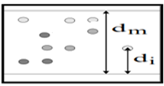

**Determination of Solubility Class**

**The Aim :** Solubility class determination gives an idea about:-

1.Type of functional group present in the cpd..

2. Polarity & the molecular weight of the cpd.. i.e.: Hydrocarbons are insoluble in water non polar nature. If an unknown cpd. is partially soluble in water, a polar functional group is present . As the M.wt. increase , the water solubility will decrease ( C ≤ 5 water soluble).

3. Nature of the compound (acidic, basic, neutral)

This is accomplished by testing the solubility of the compound in either of the following sets of solvents:

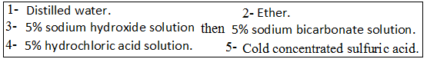

The first step to follow is to test the solubility of the compound in water. Generally and for solubility classification purposes, the compound is said to be soluble in any solvent if it dissolves to the extent of about 3 % (0.1 gm/3 ml or 0.2 mL/3 mL). This is achieved by dissolving about 0.1 gm of the solid compound or 3-4 drops of the liquid compound in gradually increasing volumes of the solvent up to 3 ml (max. allowed volume is 3 ml) with shaking.

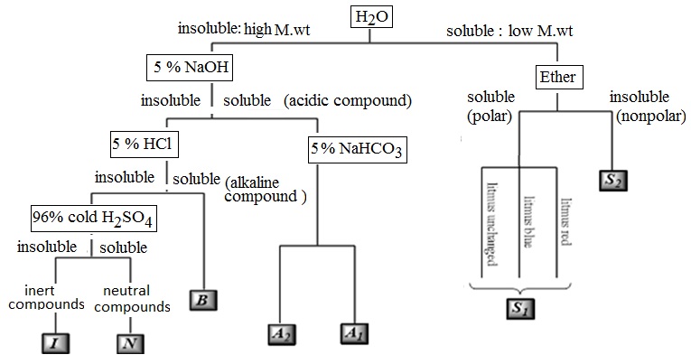

**Discussion on solvents**

* **Water**

Water is a polar solvent with a dielectric constant equals to 80. It has the ability to form hydrogen bonding and can act either as an acid or a base. Therefore it can dissolve:

* Salts of ammonium ion (RNH4+) or organic acids salts with alkali metal cations (RCOO-).
* Ionic compounds.
* Polar compounds “like dissolves like”.
* Organic compounds with low molecular weight (less than 5 carbon atoms) such as alcohols, aldehydes, ketones, and carboxylic acids.

Water is useful to determine the degree of acidity of a compound, even if the compound is insoluble in water, using litmus paper (acidic, basic, or neutral).

Water is the first solvent used to determine the solubility class of a compound. If the compound is water soluble, the next step is to test its solubility in ether.

* **Ethe**r

Ether is a non-polar solvent having a dielectric constant of 4.3. it cannot form hydrogen bonding (unassociated liquid). Therefore, it differs from water in that it cannot dissolve ionic compounds such as salts. It dissolves most water insoluble compounds; therefore, in the determination of solubility class, the importance of ether is for water-soluble compounds only and no further solubility tests using the remaining solvents are to be done.

Accordingly two probabilities are there:

1. *compounds soluble in both water and ether.*

These compounds:

* Non-ionic.
* Contain five or less carbon atoms.
* Contain an active group that is polar and can form hydrogen bonding.
* Contain only one strong polar group.

This division of compounds is given ***S1*** class and includes, e.g., aldehydes, ketones, and aliphatic acids.

1. *compounds soluble in water only* (but not in ether).

These compounds:

* Ionic.
* Contain two or more polar groups with no more than four carbon atoms per each polar group.

This group is classified as ***S2*** class and includes ionic salts such as salts of carboxylic acids and amines and compounds with more than one active group such as poly hydroxylated compounds and carbohydrates.

Note that solubility in ether is tested only for water-soluble compounds only. For water insoluble compounds use the left side of the solubility classification scheme, i.e. test solubility in sodium hydroxide rather than ether.

* **5% NaOH & 5% NaHCO3**

Water insoluble compounds must be tested first in 5% sodium hydroxide solutions which is a basic solvent. It reacts with water insoluble compounds that are capable of donating protons such as strong and weak acids. The stronger the acid, the weaker the base it can react with.

Water insoluble compounds that dissolve in 5% sodium hydroxide solution must also be tested for solubility in 5% sodium bicarbonate solution. Therefore, for water insoluble acidic compounds sodium hydroxide solution is considered as a ***detecting solvent*** whereas sodium bicarbonate solution is called as a ***sub classifying solvent*** since it can react with strong acids only.

That is, these two solvents give an idea about the acidity degree of the compound. Note that testing solubility in 5% sodium bicarbonate solution is not needed if the compound is insoluble in 5% sodium hydroxide solution, but rather, 5% hydrochloric acid solution should be used.

Two probabilities are there:

1. *compounds soluble in both bases.*

This group is given class ***A1***. This class includes strong acids that have the ability to react with weak bases (carboxylic acids) and phenols with electron withdrawing groups (e.g., –NO2). Protons are weakly attached and can be given easily.

1. *compounds soluble in 5% sodium hydroxide solution only.*This group is given class ***A2*** and it includes phenols, amides, and amino acids (weak acids).

* **5% HCl**

If the compound is insoluble in water and sodium hydroxide solution (and, hence, insoluble in sodium bicarbonate solution too), this means that the compound is not an acid but, rather, is either a basic compound or a neutral compound.

5% hydrochloric acid solution, which can dissolve basic compounds such as amines (RNH2), is used for such a compound. If the compound is soluble in this solvent, then it is given class ***B***. This class includes primary, secondary, and tertiary amines.

* **Cold concentrated H2SO4**

If the compound is insoluble in water, 5% sodium hydroxide solution, and 5% hydrochloric acid solution, solubility in cold concentrated sulfuric acid should be tested. If the compound is soluble in this acid, it belongs to class ***N*** which includes neutral compounds such as high molecular weight alcohols, aldehydes, ketones, esters, and ethers (more than four carbon atoms), and unsaturated hydrocarbons.

On the other hand, compounds that are insoluble in cold concentrated sulfuric acid belong to class ***I*** which includes inert aliphatic (saturated) hydrocarbons, aromatic hydrocarbons, haloalkanes, and aryl halides.

# Identification of Alcohols

Alcohols are organic compounds that may be considered as derivatives of water in which one of the hydrogen atoms of water molecule (H-O-H) has been replaced by an alkyl or substituted alkyl group. Therefore, properties of alcohols may be related to properties of both water and hydrocarbons.

The alkyl group could be primary, secondary, or tertiary, and may be open chain or cyclic. Accordingly, alcohols may be defined as organic compounds that contain hydroxyl groups attached to alkyl, substituted alkyl, or cyclic alkyl group.

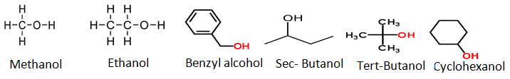

* **Physical properties**
* Alcohols are colourless liquids with a special faint odour
* Aliphatic alcohols burn with blue flame (without smoke) while aromatic alcohols burn with yellow smoky flame.
* Boiling points of alcohols are considerably high because of hydrogen bonding; its increase as the molecular weight increases.
* Low molecular weight alcohols are miscible with water while high molecular weight alcohols are immiscible with water.
* **Solubility classification**

Alcohols are polar compounds because of the presence of the hydroxyl group which is also responsible for their ability to form hydrogen bonding. The degree of the polarity depends on the size of the alkyl side chain; the polarity decreases as the size of the alkyl side chain increases.

Besides, the low molecular weight alcohols are soluble in water due to hydrogen bonding forms with water molecules. Therefore, alcohols that are soluble in water and ether are classified under class ***S1*** such as ethanol and methanol. Alcohols that are insoluble in water are related to class ***N*** such as benzyl alcohol, *sec*-butanol, and cyclohexanol.

* **Chemical properties**
* Alcohols are neutral compounds that don’t change the colour of litmus paper.
* All reactions of alcohols are related to its active hydroxyl group and are of two types:

1. Removal of the hydroxyl itself as in the reaction with hydrogen halides to form alkyl halides or in the dehydration reaction to form a double bond.
2. Removal of the proton only from the active hydroxyl as in the formation of esters or in the reaction with active metals such as sodium.

* **General test (Ceric ammonium nitrate)**

Ceric ammonium nitrate (yellow solution) is an oxidizing agent that reacts with alcohols to give a red complex and with phenols to give a brown to greenish brown precipitate.

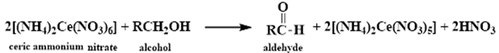

The red coloured complex is an intermediate for the oxidation of alcohols by the Ce (IV) solution. This red colour disappears after a reasonable time due to completing the oxidation of this intermediate and the reduction to the colourless Ce (III) solution producing the corresponding aldehyde or ketone.

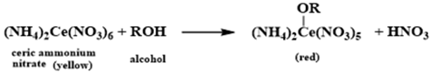

**Procedure**

* *Water soluble (miscible) alcohols*;

Mix two drops of the alcohol with one drop of ceric ammonium nitrate solution. A red complex indicates a positive test.

* *Water insoluble (immiscible) alcohols*;

Mix two drops of the alcohol with 0.5 ml dioxane, shake well, and add one drop of the reagent to get a positive red complex.

This test gives positive results with primary, secondary, and tertiary alcohols (up to 10 carbons), poly hydroxylated compounds such as carbohydrates, and hydroxylated carboxylic acids, aldehydes and ketones.

* **Classification test (Lucas test)**

This test often provides classification information's on alcohols and is used to distinguish between the different types of alcohols (primary, secondary, or tertiary). It depends on the formation of alkyl chloride as a second liquid phase.

Lucas reagent is prepared from anhydrous zinc chloride and conc.hydrochloric acid. Zinc chloride is added to increase the ionization of hydrochloric acid.



**Procedure**

Mix 2-4 drops of the alcohol with few drops of Lucas reagent and observe the results:

* Benzyl alcohol gives immediate result as shown by the appearance of two phases.
* Tertiary alcohols give two phases that separate within 2-3 minutes.
* Secondary alcohols give two phases that separate after 15-20 minutes (giving a cloudy solution).
* Primary alcohols one layer appears (not reacts).

**Identification of Aldehydes and Ketones**

Aldehydes are compounds of the general formula RCHO; ketones are compounds of the general formula RŔCO. The groups R and Ŕ may be aliphatic or aromatic, and in one aldehyde, formaldehyde, R is hydrogen.

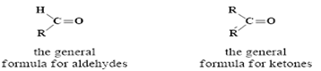

Both aldehydes and ketones contain the carbonyl group C=O and are often referred to collectively as carbonyl compounds. It is this carbonyl group that largely determines the chief chemical and physical properties of aldehydes and ketones.

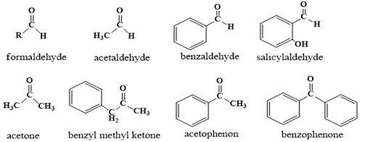

The relationship between alcohol aldehydes and ketones is an oxidation-reduction relation. Oxidation of alcohols yields an aldehyde and ketone while reduction of aldehyde and ketone yields alcohols.

* **Physical properties**
* Low m.wt aldehydes and ketones are liquids except formaldehyde, which is gas (boiling point -21˚C). Formaldehyde is handled either as an aqueous solution (*formalin*, 40% formaldehyde and 15% methanol.) or as one of its solid polymers: paraformaldehyde, (CH2O)n, or trioxane, (CH2O)3.
* Low molecular weight aldehydes and ketones (less than 5 carbons) are appreciably soluble in water, although they do not have the ability to form hydrogen bonds (unlike alcohols), high molecular weight (aromatic ones) is insoluble in water, and all of them are soluble in organic solvents.
* The boiling points of aldehydes and ketones are lower than those of the alcohols from which they are derived; isopropyl alcohol boils at 82.5˚C while its oxidation product, acetone, boils at 56˚C, because they do not have the ability to form hydrogen bonds .
* Aliphatic aldehydes and ketones burn with a blue flame (without smoke) while aromatic ones burn with a yellow smoky flame.
* **Solubility classification**

Aldehydes and ketones that are soluble in water are soluble in ether too and are classified under class ***S1***(*e.g.*, formaldehyde and acetone).Aldehydes and ketones that are insoluble in water are classified under class ***N*** such as benzaldehyde and benzophenone.

* **Chemical properties**
* All reactions of aldehydes and ketones are related to the carbonyl group (the active group).
* Aldehydes have a hydrogen atom attached to its carbonyl while ketones don’t.This difference in their structure affectsin :two ways:

1. Aldehydes are easily oxidized to the corresponding acids and have reducing properties while ketones are not oxidized under similar conditions and do not show reducing properties.
2. Aldehydes are usually more reactive than ketones towards nucleophilic addition, the characteristic reaction of carbonyl group.

* aldehydes and ketones are neutral don’t change the color of litmus paper.
* **General test (2,4-Dinitrophenylhydrazine)**

Both aldehydes and ketones give yellow or orange precipitate with 2,4-dinitrophenylhydrazine reagent.

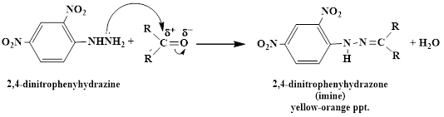

**Procedure**

To 2 drops of the compound add 3 drops of the reagent, a yellow or orange precipitate will be formed. If the compound is insoluble in water, dissolve it in 1 mL of methanol and then add the reagent.

* **Differentiation between aldehydes and ketones**

Differentiation between aldehydes and ketones is achieved by taking the advantage of the fact that aldehydes can be easily oxidized while ketones cannot (they need stronger oxidizing agents).Two reagents can be used for this purpose, Tollen’s reagent or Fehling’s reagent. Only aldehydes give positive results .

1. **Tollen's test (Reduction of ammoniacal silver nitrate)**

Tollen’s reagent is the combination of silver nitrate solution with ammonium hydroxide in the presence of sodium hydroxide solution. Aldehydes show positive result with this reagent because the reaction between them involves the oxidation of the aldehyde to the corresponding carboxylic acid with an accompanying reduction of the silver ions from this reagent to silver element in the form of silver mirror on the inner side of the test tube.

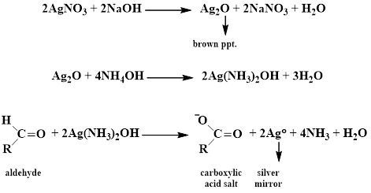

The oxidation process requires an alkaline medium; therefore sodium hydroxide solution is used, and in order to overcome the formation of the brown silver oxide precipitate (Ag2O), ammonium hydroxide is used to serve as a complexing agent for this precipitate making it a water soluble complex. Note that since the medium is alkaline, salts of the produced carboxylic acid are formed rather than the acid itself.

**Procedure**

* Preparation of Tollen’s reagent

To 3mL of silver nitrate solution add 2-3 drops of 10% sodium hydroxide solution, and then add drop wise very dilute ammonia solution with continuous shaking until all the brown precipitate of silver oxide is dissolved. This reagent should be freshly prepared prior before use.

* Add 2-3 drops of the compound to 2-3 mL of Tollen’s reagent, a silver mirror will be formed. If no reaction occurs, warm the test tube in water bath for few minutes (excessive heating will to a false positive test by decomposition of the reagent).

silver mirror can be washed by dilute nitric acid. If the test tube is not very clean, silver metal forms as a granular gray or black precipitate. water insoluble aldehydes give false-negative tests. A negative result indicates that the compound is a ketone.

1. **Reduction of Fehling's reagent**

Only aldehydes can reduce Fehling’s reagent (a deep blue solution) to give a red cuprous oxide precipitate.

**Procedure**

* Preparation of Fehling's reagent

Fehling’s reagent is prepared by mixing exactly equal volumes of Fehling’s A and Fehling’s B solution in a 1:1 ratio immediately before use (usually 1 mL of each).

Fehling’s A solution is an aqueous solution of copper sulfate pentahydrate (CuSO4.5H2O) with few drops of concentrated sulfuric acid whereas Fehling’s B solution is an aqueous solution of potassium sodium tartrate (C4H4KNaO6,4H2O) and sodium hydroxide.

* Add 5 drops of the compound to 1 mL of Fehling’s solution, and then heat in water bath for 5 minutes (with shaking for water insoluble compounds).

Aldehydes change the color of Fehling’s solution from blue to green, orange precipitate, and then red precipitate or copper mirror. Ketones don’t change the color of this reagent. On the other hand, this test does not give a sharp result with aromatic aldehydes.

**Identification of Phenols**

Phenols are organic compounds with a hydroxyl group attached directly to benzene or substituted benzene. They have the general formula Ar-OH.

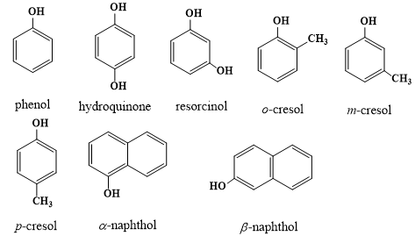

**Physical properties**

* Phenols are liquids (*o-* and *m-*cresol) or solid crystalline compounds (phenol and resorcinol).
* They are coloured due to air oxidation and have a special odour. Pure compounds are colourless.
* They have high boiling points because of intermolecular hydrogen bonding.
* Phenol itself is soluble in water due to its ability to form hydrogen bonding with water. For other phenols the solubility in water decreases by increasing the molecular weight. (Cresols and naphthols are insoluble in water).
* Phenols burn with a yellow smoky flame due to the presence of aromatic ring.
* **Chemical properties**

Phenols are weak acidic compounds, so they are soluble in strong alkaline solutions only (sodium hydroxide solution). For this reason they fall into solubility class ***A2***. Presence of electron withdrawing group at the phenyl ring strengthens the acidity of the phenol making it of solubility class ***A1*** (nitrophenol). However, phenol itself is of solubility class ***S1***since it is water soluble.

* **Types of phenols reactions**

1. Reactions at the phenolic hydroxyl group (-OH); *e.g.*, ether formation and salt formation:

* Phenol reacts with sodium hydroxide to form sodium phenoxide.

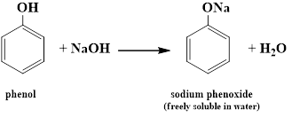

* Ethyl phenyl ether is formed when phenol reacts with ethyl iodide.

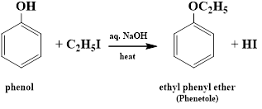

1. Substitution at the aromatic ring; *e.g.*, bromination and nitration reactions:

* Reaction with bromine water.

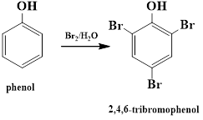

* Reaction with dilute nitric acid.

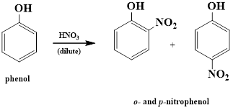

* **Chemical reactions**

**Reaction with ferric chloride**

Phenols react with ferric chloride to give coloured compounds due to the presence of the enol group. Actually this reaction is considered as a test for any compound with enol group



To a very dilute aqueous solution of the phenol (30-50 mg in 1-2 mL water) or to a few crystals of the solid phenol (50-100 mg) dissolved in water add 1 drop of ferric chloride solution and observe the resulting colour:

|  |  |
| --- | --- |
| **compound** | **colour** |
| **phenol, *m*-cresol, resorcinol** | **violet or blue** |
| ***o-* and *p-*cresol** | **greenish blue** |
| **hydroquinone** | **deep green** |
| ***α*- and  *β*-naphthol** | **no special colour** |

Hydroquinone undergoes oxidation in the presence of ferric chloride resulting in a deep green solution (crystals may separate) and, on further addition of ferric chloride solution, a yellow solution of *p*-benzoquinone is produced:

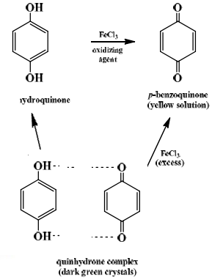

**Identification of Carboxylic Acids**

Carboxylic acids are organic compounds that have a carboxyl group attached to an alkyl group (RCOOH) or to an aryl group (ArCOOH). The 'R' may be a hydrogen and the result is formic acid. They may be mono carboxylated, multi carboxylated, substituted (*e. g.,* hydroxyl groups), or they may be aromatic

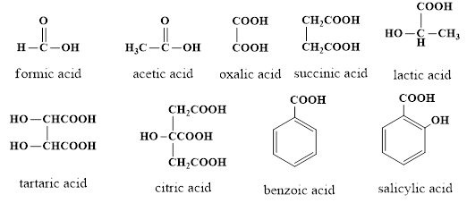

**Physical properties**

* Some carboxylic acids are liquids at room temperature others are solids.
* Low molecular weight carboxylic acids are soluble in water and, therefore, lie under class ***S1***. Water insoluble acids dissolve in both sodium hydroxide solution and sodium bicarbonate solution, being classified under class ***A1***. When they react with sodium bicarbonate, they evolve carbon dioxide gas. This is considered as a good simple indication of them.
* Their boiling points are generally high due to the association through hydrogen bonds: two molecules of the carboxylic acid are held together by two hydrogen bonds rather than one.

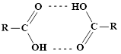

* Aromatic carboxylic acids burn with a yellow smoky flame whereas aliphatic ones burn with a blue flame without smoke.

**Chemical properties**

The acidic properties of carboxylic acids are attributed to the proton of the carboxyl group. Mono carboxylic acids are weak acids except formic acid, which is the strongest. The tendency of the alkyl group to release electrons weakens the acid; thus formic acid is the strongest. On the other hand presence of electron withdrawing groups (such as halogens) especially on the alpha carbon increases the acidity.

**Types of carboxylic acids reactions**

* The proton as in salt formation reactions.
* Removal of the hydroxyl group as in conversion to derivatives such as esters, amides, or acid chlorides.
* Substitution either in the alpha position of aliphatic acids or in the meta position of aromatic ones.
* **Chemical reactions**

**General test (Ferric chloride test)**

The acid solution should be made neutral before performing the test with ferric chloride solution. This is achieved by adding very dilute ammonia solution drop by drop with shaking to a solution of about 0.5 g of the solid acid or 2 drops of the liquid acid in 1 mL water until the medium becomes basic as indicated by changing the colour of litmus paper to blue or changing the colour of phenolphthalein indicator from colorless to pink, in which case the characteristic odour of ammonia is predominant. At this stage the solution is slightly basic.

To convert the solution neutral the excess ammonia should be removed by gently heating the test tube in a water bath with shaking from time to time until both the odour of ammonia and the pink colour disappears. Cool the solution and then add few drops of ferric chloride solution to get different colours (solutions or precipitates) as follows:

|  |  |
| --- | --- |
| **carboxylic acids** | **Result** |
| formic and acetic | red solution |
| succinic and benzoic | light brown precipitate |
| salicylic | violet solution |
| oxalic, tartaric, citric, and lactic | no special change |

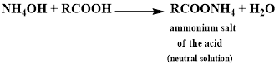



When the solution is ***basic*** (excess ammonia):

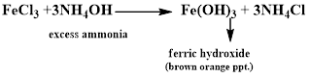



Therefore elimination of the excess ammonia is important since the brown orange precipitate of ferric hydroxide formed by this excess interferes with the colour of the ferric salt of the acid resulting in a false result.

If the solution is still ***acidic*** (little ammonia is added), colourless complexes are formed between the acid and ferric ions, a false negative result.



**Identification of Carboxylic Acids Salts**

Carboxylic acids salts are organic compounds with the general formula (RCOOM) where (RCOO-) refers to the carboxylic acid part and (M+)is the alkali part which, in this experiment, may be either a metal cation (Na+ or K+) or ammonium (NH4+). These salts are colourless or white crystalline solids and are soluble in cold or hot water.

* **Identification of the carboxylic acid part (anionic part)**

The carboxylic acid part can be identified by the usual steps for identification of carboxylic acids starting with ferric chloride test and, according to the result observed; the proper special test should be performed then to conclude the carboxylate name (formate, lactate, salicylate, etc.).

* **Identification of the alkali part (cationic part)**

**1-Identification of sodium or potassium cations**

Place about 0.1 g of the salt on the edge of a metal spatula and start heating it gently on a flame with gradual increase in the heat strength. Sodium and potassium salts leave a residual amount of solid on the spatula in addition to the carbon coming from decomposition of the organic part. This residual solid may be sodium carbonate or potassium carbonate and can be detected, after cooling, by the addition of few drops of dilute hydrochloric acid solution which results in a strong effervescence within the residual solid due to liberation of carbon dioxide gas:

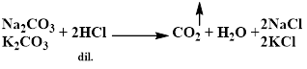

During ignition observe the colour of the flame. Sodium salts burn with a golden yellow flame whereas potassium salts burn with a purple flame.

**2- Identification of ammonium cation**

Repeat the ignition procedure mentioned above and note that ammonium salts don't leave any residual solid except the carbon coming from decomposition of the organic part. After cooling, addition of few drops of dilute hydrochloric acid does not result in any effervescence.

Ammonium cation can be detected as follows. Place few crystals of the salt in a test tube and add 0.5 mL of 10% sodium hydroxide solution. At this stage free ammonia is liberated and can be smelt easily:



Place a small filter paper over the top of the tube and fold it down around the tube. Add 2 drops of 10% copper sulphate solution on the filter paper covering the mouth of the test tube. Heat the test tube mildly on a flame to boil the mixture. The liberated ammonia will react with the copper ions present on the filter paper resulting in a blue colour.

**Important terms used in calculations involved in analytical chemistry**

Below is a brief review of certain terms used in analytical chemistry

$$no.of moles=\frac{weight (g)}{molecular weight (g/{mole)}}$$

$$no.of equivalents=\frac{weight (g)}{equivalent weight (g/{eq.)}}$$

* **Molarity** is an expression used to determine the concentration of a solution in terms of number of moles of the reagent per liter of the solution.
$$Molarity (M)=\frac{no.of moles}{volume of solution (L)}$$

* **Normality** is an expression used to determine the concentration of a solution in terms of number of equivalents of the reagent per liter of the solution
$$Normality (N)=\frac{no.of equivalents}{volume of solution (L)}$$

* **A** **standard solution** is a solution of known normality or molarity.

**Standardization**is the determination of the molarity or normality of a solution by titration.

Standardization may be done by:

1. The use of another standard solution, **the secondary standard**.
2. The use of a carefully weighed sample of a substance of a high purity, **the primary standard**.

The primary standard should:

1. Of high purity and known composition.
2. Stable.
3. Not be hygroscopic or efflorescent.
4. Readily available and of low cost.
5. Have high equivalent weight to minimize errors during weighing.
6. Reasonably soluble in the titration medium.

* ***Titration*** is an analytical technique which allows the quantitative determination of a specific substance (analyte) dissolved in a sample. It is based on a complete chemical reaction between the analyte and a reagent (titrant) of known concentration which is added to the sample. A well-known example is the titration of acetic acid (CH3COOH) in vinegar with sodium hydroxide,



The titrant is added until the reaction is complete at the end point. The end of a titration reaction should, then, be easily observable mostly by colour indicators. The reaction involved in a titration must be fast, complete, of known mechanism and observable.

Titration reaction types include

* Acid-base reactions,
* Oxidation-reduction reactions,
* Complexometric reactions, and
* Precipitation reactions.

**The preparation and standardization of 1 *N* hydrochloric acid**

* **Chemical principle**

Hydrochloric acid is standardized against sodium carbonate as the primary standard in an acid- base titration.



**Procedure**

1. Preparation of 100 ml of 1 *N* HCl.

Dilute 9 mL of HCl with distilled water to a final volume of 100 mL using a suitable volumetric flask.

1. Standardization

* Wash the burette with the D. W. and the titrant (HCl).
* Fill the burette with HCl to a level (adjust it).
* Dissolve the primary standard (Na2CO3) in enough D. W. (100 mL) using the conical flask(anhydrous sodium carbonate (mol. wt. 106) has been previously heated to about 270 ° C for 1 hr to be used as the primary standard).
* Add 2 drops of methyl red.
* Start titration by adding HCl drop wise with continuous stirring until the solution becomes faint pink.
* Heat the solution to boiling so that the colour changes back into yellow, cool, and titrate again until the faint pink colour is no longer affected by boiling.
* Record the volume of HCl used and calculates the normality, as the following equation: $N ×V = \frac{wt.}{eq.wt.} ×1000$

Where *N* is the normality of HCl to be calculated

*V* is the volume of HCl used in mL (from burette)

*wt.* is the weight of sodium carbonate in g (unknown wt.)

*eq. wt.* is the equivalent weight of sodium carbonate

* **Notes:**

1. During titration carbon dioxide is liberated and this will react with water to produce carbonic acid. This latter is responsible for the false early end point as it reacts with sodium carbonate to produce sodium bicarbonate. Heating will make sodium bicarbonate dissociate back into sodium carbonate, water, and carbon dioxide which will be expelled as a gas.



1. The volume of concentrated HCl used (9 mL) in the dilution was

calculated by the following equation:

$$N_{1} × V_{1} = N_{2} × V_{2}$$

Where *N1* is the normality of concentrated HCl used  
 *V1* is the volume of concentrated HCl to be used for dilution  
 *N2* is the requested normality of HCl (1 *N* in this experiment)  
 *V2* is final volume after dilution (100 mL in our experiment)

1. The normality of the concentrated HCl is calculated from the following equation:

$$N = \frac{\%*sp.gr.*1000}{eq.wt.}$$

Where *N* is the normality of the concentrated acid  
 *%* is the weight by weight concentration of the acid  
 *sp. gr.* is the specific gravity of the acid  
 *eq. wt.* is the equivalent weight of the acid

1. In preparing volumetric solutions, it is well to be on the safe side and take a little more than the calculated volume of the concentrated reagent, since it is much easier to dilute a concentrated solution than to strengthen one that is too weak.

**The preparation and standardization of 1 *N* sodium hydroxide solution**

* **Introduction**

Sodium hydroxide is a strong base that is usually used to prepare standard alkaline solutions useful for volumetric analysis of acidic compounds. Sodium hydroxide is hygroscopic and can react with atmospheric carbon dioxide. Thus it is usually contaminated with water and sodium carbonate.

That is why it is difficult to obtain the exact normality when a standard sodium hydroxide solution is required. Standardization against a primary standard of acidic nature is important then, although standardization against standard hydrochloric acid is sometimes applied.



* **Chemical principle**

Sodium hydroxide solution is standardized against any of the following primary standards in an acid- base titration: potassium hydrogen phthalate, benzoic acid, succinic acid, and potassium hydrogen iodate.



or secondary standard solution like standard HCl solution.

**Procedure**

1. Preparation of 100 mL of 1 *N* sodium hydroxide solution.

Dissolve 4.5 g of sodium hydroxide in 100 mL distilled water, allow cooling, and then adding saturated barium hydroxide solution drop wise with stirring until a precipitate is formed. Leave aside allowing for complete precipitation, filter, and collect the filtrate to be standardized against a suitable standard solution.

1. Standardization.

* Wash the burette with the D. W. and the titrant (NaOH).
* Fill the burette with NaOH to a level (adjust it).
* Wash a 20 mL – bulb pipette with D. W. then by a little of HCl solution; fill it. to the mark with the acid.
* Transfer the acid into a clean conical flask; add D.W. (50 mL).
* Add 2 drops of phenolphthalein indicato. Start titration by adding NaOH solution drop wise with continuous stirring until the solution changes from colourless to pink.
* Record the volume of NaOH solution used and calculate the normality.
* **Calculation**

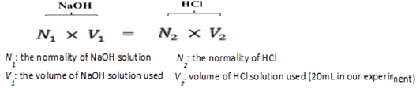

Note:

1. Barium hydroxide solution is used to precipitate the contaminating soluble sodium carbonate as insoluble barium carbonate thereby liberating back sodium hydroxide.



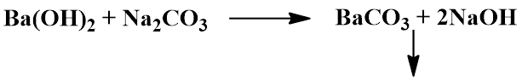

1. The quantity of sodium hydroxide needed to prepare 100 mL of 1*N* solution is calculated using the mathematical equation

$N ×V = \frac{wt.}{eq.wt.} ×1000$

(Calculations would show that 4 g are needed, but practically 4.5 g were used, why?).

**Assay of sodium benzoate**

* **Introduction**

Sodium benzoate (C7H5NaO2, m. wt. = 144.1) is a white, crystalline or granular powder or flakes. It is slightly hygroscopic, freely soluble in water, and sparingly soluble in alcohol. The powder when dried contains not less than 99 % of sodium benzoate. Sodium benzoate has antibacterial and antifungal properties. It is used as a preservative in pharmaceutical formulations including oral preparations in conc.s up to 0.5 %. Sodium benzoate is also an ingredient of cough preparations.

* **Aim of the experiment**

calculate the percent content (w/v) of sodium benzoate in an unknown solution.

* **Chemical principle**

Sodium benzoate is a salt derived from a weak acid and a strong base, so its aqueous solution is alkaline. Therefore, solutions containing sodium benzoate are assayed using a standard *N*/2hydrochloric acid solution in an acid- base titration.

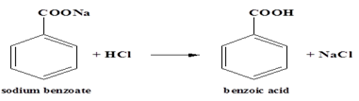

Unlike sodium benzoate, the liberated benzoic acid (as precipitate) is slightly soluble in water but is highly soluble in organic solvents as ether.

**Procedure**

* Wash the burette with the D. W. and the titrant (HCl). with *N*/2 HCl to a level (adjust it) then Fill the burette
* Put 10 mL of an unknown sodium benzoate solution in a clean conical flask.
* Add 25 mL of D. W. and 15 mL of ether then add 6 drops of bromophenol blue.
* Start titration by adding HCl drop wise with shaking to aqueous and ethereal layers until a light green colour persists in the aqueous layer (end point).
* Record the volume of HCl used.
* **Chemical Factor**

Each 1 mL of *N*/2 hydrochloric acid is equivalent to 0.07205 g of C7H5NaO2. So:

**Notes:**

Ether is added to extract the liberated benzoic acid so that preventing it from interfering with the end point.

* **Calculation** 1. Calculate the chemical factor:

2. Correct the volume of HCl solution used into *N*/2 volume.

3. Calculate the quantity of sodium benzoate present in your sample.

4. Calculate the percentage w/v of you sodium benzoate sample.

**Assay of citric acid**

* **Introduction**

Citric acid (C6H8O7, m. wt. = 192.09) is a white crystalline powder (or colourless crystals). It is very soluble in water and freely soluble in alcohol. It is a tri-basic acid, so its solutions are strongly acidic. It is available as the anhydrous form or monohydrate form. Assay of citric acid is based on the anhydrous form.

Citric acid liberates carbonates, so it is used widely in effervescent salts. Citric acid is also used to dissolve renal stones.

* **Aim of the experiment**

In this experiment you will calculate the percent content (w/v) of citric acid in an unknown solution.

* **Chemical principle**

Since citric acid has strong acid properties, it is titrated against a standard basic solution like *N*/1 NaOH solution in an acid- base reaction.



**Procedure**

* Weigh accurately 1 g of citric acid (or you may take 10 mL of an unknown citric acid solution).
* Dissolve in 20 ml of distilled water.
* Add 2 drops of phenolphthalein solution as the indicator.
* Titrate with *N*/1 sodium hydroxide solution until you get a faint pink colour.
* **Chemical Factor**

Each 1 mL of *N*/1 sodium hydroxide solution is equivalent to 0.06403 g of C6H8O7. This is calculated as follows:

$$1 mol.wt.of citric acid ≡3 mol.wt.of NaOH$$

$$1 eq.wt.of citric acid ≡1 eq.wt.of NaOH$$

$\frac{192.09}{3} g of citric acid ≡1 eq.wt. NaOH$

$64.03 g citric acid≡1 L of 1 NNaOH$

$0.06403g citric acid≡1 mL of 1 NNaOH$

* **Calculation**
* Calculate the chemical factor:

(each 1 mL of *N*/1 sodium hydroxide solution is equivalent to 0.06403 g of C6H8O7).

* Correct the volume of NaOH solution used into *N*/1 volume.
* Calculate the quantity of citric acid present in your sample.
* Calculate the percentage w/v of you citric acid sample.

**Assay of magnesium hydroxide**

* **Introduction**

Magnesium hydroxide (Mg(OH)2, m. wt. = 58.32) is white or almost white, fine, amorphous powder. It is practically insoluble in water but dissolves in dilute acids. Its solution in water is alkaline.

It is an antacid(known as milk of magnesia) given orally.It is given as an osmotic laxative and used as a food additive and a magnesium supplement in deficiency states.

* **Aim of the experiment**

To find out the weight of an unknown sample of magnesium hydroxide.

* **Chemical principle**

Assay of magnesium hydroxide should follow acid- base reaction in which a standard acid is used. Magnesium hydroxide is insoluble in water, direct titration is not possible. Thus, ***back* or *residual titration*** is employed here. The residual titration is accomplished by dissolving the substance under estimation in an accurately measured excess quantity of a standard solution of known strength, and titrate the excess of the latter with another previously standardized solution.

Residual titration is usually carried out when the substance under estimation:

1. Is insoluble in water (e. g., magnesium hydroxide and calcium carbonate; which require excess of the standard solution to be solubilized).
2. Fails to give a sharp end point with the indicator used in direct titration.
3. volatile (e. g., ammonia; some of which would be lost during the titration).
4. Reacts rapidly only in the presence of excess of the standard solution (e. g., aspirine and lactic acid).
5. Decomposes when heated with the standard solution (e. g., formaldehyde; heating is required during titration).

Magnesium hydroxide is dissolved in excess 1 *N* sulphuric acid and the unreacted excess of this acid is to be back titrated against 1 *N* sodium hydroxide solution:



**Procedure**

* Dissolve the accurate measured unknown sample of magnesium hydroxide in 30 ml of distilled water then add 20 mL of 1 *N* sulphuric acid.
* Add 2 drops of methyl-orange solution as the indicator.
* Titrate against 1*N* sodium hydroxide solution until reaching the end point(yellow).
* **Chemical Factor**

Each 1 mL of 1 *N* sulphuric acid solution is equivalent to 0.02916 g of magnesium hydroxide. This is calculated as follows:

$$1 mol.wt.of Mg(OH)_{2} ≡1 mol.wt.of H_{2}SO_{4}≡2 mol.wt.of NaOH$$

$$1 eq.wt.of Mg(OH)_{2} ≡1 eq.wt.of H_{2}SO_{4}$$

$\frac{58.32}{2} g of Mg(OH)_{2} ≡1 eq.wt. H_{2}SO_{4}$

$29.16 g Mg(OH)_{2}≡1 L of 1 NH_{2}SO_{4}$

$0.02916 g Mg(OH)_{2}≡1 mL of 1 NH_{2}SO_{4}$

* **Calculation**
* Calculate the chemical factor:

(each 1 mL of 1 *N* sulphuric acid solution is equivalent to 0.02916 g of

magnesium hydroxide)

* Correct the volumes of NaOH and H2SO4 solutions used into *N*/1 volume:
* Calculate the quantity of magnesium hydroxide present in your sample:

*V1*  – *V2* = *V3* the volume of *N*/1 H2SO4 consumed by the unknown

*V1* is the volume of H2SO4 added

*V2* is the volume of NaOH reacted with the excess H2SO4

*wt.*= *V3* * *chemical factor*

**Oxidation-Reduction Method (Redox Method)**

Oxidation-Reduction Method (Redox Method) of analysis involve a change in valance of reacting substance. There is always a transfer of electrons.

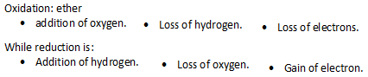

In all oxidation-reduction processes (or redox processes) there will be a one reactant undergoing oxidation and other one undergoing reduction, since the two reactions are complementary to one another and occur simultaneously.

* **The oxidation number** (O.N.) of an element is a number which, applied to that element in a particular compound, *indicates the amount of oxidation or reduction which is required to convert one atom of the element from the* ***free state*** *to that in the compound.* If oxidation is necessary to effect the change, the oxidation number is positive, and if reduction is necessary, the oxidation number is negative.
* The following rules apply to the determination of oxidation numbers.

1. The O.N. of the free or uncombined element is zero.

2. The O.N. of hydrogen (except in certain hydrides) has a value of + 1.

3. The O.N. of oxygen (except in peroxides) is -2.

4. The O.N. of a metal in combination (except in hydrides) is usually positive.

5. The O. N. of a radical or ion is that of its electronic charge with the correct sign

attached.

6. The O.N. of a compound is always zero, and is determined by the sum of the

oxidation numbers of the individual atoms each multiplied by the number of

atoms of the element in the molecule.

**oxidation number is an indicator of the degree of** [**oxidation**](http://en.wikipedia.org/wiki/Oxidation) **of an** [**atom**](http://en.wikipedia.org/wiki/Atom) **in a** [**chemical compound**](http://en.wikipedia.org/wiki/Chemical_compound)**.**

The increase in oxidation number of an atom through a chemical reaction( net loss of electrons) is known as an oxidation; a decrease in oxidation number(net gain in electrons) is known as a [reduction](http://en.wikipedia.org/wiki/Redox). For pure elements, the oxidation number is zero.

The complete rules for the application of the ion-electron method may be expressed as follows:

a) As certain the products of the reaction;

b) Set up a partial equation for the oxidizing agent;

c) Set up a partial equation for the reducing agent in the same way;

d) Multiply each partial equation by a factor so that when the two are added the

electrons just compensate each other ;

e) Add the partial equations and cancel out substances which appear on both sides of the equation.

**The preparation and standardization of 0.1 *N* potassium permanganate solution**

* **Introduction**

Potassium permanganate (KMnO4, m. wt. =158.0) is a dark purple or brownish black powder or dark purple or almost black crystals. It is soluble in cold water and freely soluble in boiling water. It is a strong oxidizing agent. It decomposes on contact with certain organic substances.It is widely used as a standard (volumetric) oxidizing solution because of its intense colour which serves as an indicator in titrations besides its low cost.

* **Aim of the experiment**

One liter of 0.1 *N* potassium permanganate solution is to be prepared.

* **Chemical principle**

Standardization of potassium permanganate against sodium oxalate (as the primary standard) follows oxidation-reduction reaction in which potassium permanganate is the oxidizing agent where as sodium oxalate is the reducing agent. The titration is carried out in acid medium.



**Procedure**

1. Preparation of 1000 ml of 0.1 *N* KMnO4 solution.

Weigh out approximately the appropriate amount of potassium permanganate (3.2 g, *why?*) using a watch-glass. Transfer into a 250- mL beaker containing water and stir thoroughly breaking up the crystals with a glass rod, to effect solution. Allow to stand for at least 2 days.

Filter the solution through a small plug of glass- wool supported in a funnel, in to a one-liter volumetric flask, leaving the undissolved residues in the beaker. Add more water to the beaker and repeat the process several times until all the potassium permanganate has dissolved. Make the solution up to the graduation mark by addition of water, and shake well to ensure thorough mixing. Store in a dark clean closed- container.

1. Standardization

* Rinse and Fill the burette with prepared KMnO4 soln.
* Accurately weigh 0.2 g of anhydrous sodium oxalate (mol. wt. 134) previously dried to 110 °C and dissolve it in 100 mL of water,
* Add 7 mL of sulphuric acid and heat to about 70 °C.
* Then slowly add the permanganate solution from the burette with constant shaking. The first few drops result in a pink colour persisting for about 20 seconds. Wait until the colour disappears and then continue the titration in the usual manner.
* The end point is reached when a faint pink colour persists for about 30 seconds upon shaking the flask. **Note** that the temperature of the medium should not be less than 60°C throughout the titration.
* Record the volume of KMnO4 solution used and calculate the normality using the following equation:

$N ×V = \frac{wt.}{eq.wt.} ×1000$

*eq. wt.* is the equivalent weight of sodium oxalate (67)

* We can calculate the eq.wt. of the reactants:



* ***Permanganate* ion** (MnO4‾ ) acts as an oxidizing agent in acidic media, being reduced to Mn⁺⁺:



* Oxalate ion (C2O4⁼)acts as reducing agent:

C2O4⁼ 2CO2 + 2e‾

**Discussion**

* KMnO4 is widely used in volumetric analysis as a standard oxidizing agent because:

1. It is strong oxidizing agent.
2. The intense color of KMnO4 solution is sufficient to signal the end point in most titrations thus it is used as self-indicator.

* On the other hand,

1. KMnO4 is a strong oxidizing agent, and then it will oxidize any organic matter present in D.W.
2. KMnO4 soln. is allowed to stand for 2days to ensure the completion of the decomposition reaction.
3. It is filtered through asbestos to remove all traces of manganese dioxide (MnO2).
4. KMnO4 is unstable in the presence of direct sunlight, organic matter (Filter paper).
5. H2SO4 is added since KMnO4 is better oxidizing agent in acidic media, H2SO4 is added to keep [H⁺] ion conc. constant throughout the titration.
6. Heat to about 70 ***◦***c because the oxidation of sod. oxalate is rapid enough if the temp. above 60 ◦c .

* **Sod. oxalate, not oxalic acid, is used because:**

1. The salt can be obtained in very pure condition.
2. Free from water of crystallization.
3. It can be dried to 130◦c without decomposition and it is stable to air.

The chemical equation for the standardization of pot. Permanganate:



* **Calculation**

KMnO4 Na2C2O4

$\text{N×V} = \frac{Wt}{eq.wt(67gm/mole}\text{×}1000$

**Assay of hydrogen peroxide solution**

* **Introduction**

Hydrogen peroxide (H2O2, m. wt. =34.02) is a colourless liquid that is miscible with water in all proportions. It is usually available as 3%, 6%, and 30% solutions. It is a powerful oxidizing agent, both in acidic and basic solutions. It is used as an antiseptic, disinfectant, and deodorant (mouthwashes) besides its use as a bleaching agent.

Hydrogen peroxide solutions are incompatible with reducing agents, including organic matter and oxidizable substances, and with some metals (copper, iron, manganesealkalis, iodides, permanganates, and other stronger oxidizing agents. Aqueous solutions of hydrogen peroxide gradually decompose on standing and if allowed to become alkaline. Decomposition is increased by light, agitation, and heat. Solutions are comparatively stable in the presence of a slight excess of acid. Strong solutions are considered to be more stable than weak. Its solution should be stored in airtight containers at about 15° C.

The decomposition of hydrogen peroxide by the aid of catalysts is an example of *disproportionation reactions* (also known as self-oxidation reaction). Here it is both oxidized and reduced to produce oxygen gas and water:



The volume of this oxygen gas reflects the *volume strength* of hydrogen peroxide solution which is the number of milliliters of oxygen at normal temperature and pressure (NTP) that can be obtained by complete thermal decomposition of 1 mL of solution.

* **Aim of the experiment**

In this experiment you will find out the percentage (*w/v*) of an unknown sample of hydrogen peroxide solution.

* **Chemical principle**

Hydrogen peroxide is assayed against 0.1 *N* potassium permanganate solution in acidic medium following oxidation- reduction reaction.



**Procedure**

Dilute 10 mL of the unknown solution to 200 mL with water. To 20 ml of the diluted solution add 5 mL of 50% v/v sulphuric acid and titrate with 0.1 *N* potassium permanganate solution until getting a persistent faint pink colour.

**Notes:**

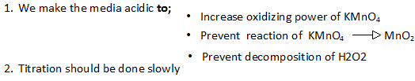

**Calculations**

Each 1 mL of 0.1 *N* KMnO4 is equivalent to 0.001701 g of H2O2. This is calculated as follows: $5 mol.wt.of H_{2}O_{2} ≡2 mol.wt.of KMnO_{4}$

$170.1 g of H_{2}O_{2} ≡10 eq.wt.of KMnO_{4}$

$17.01 g of H_{2}O_{2} ≡1 L of 1 N KMnO_{4}$

$0.001701 g H_{2}O_{2}≡1 mL of 0.1 N KMnO_{4}$

Correct the **volume** of KMnO4  NxV = N’xV’ (corrected)

* Multiply the corrected volume by the Ch. Factor to get the weight of H2O2
* The **%w/v** of H2O2 = **wt**. /10 x 100 wt. weight

This percent represent the percent of H2O2 in 10 ml of the sample.

Now, having the percentage w/v known you can calculate the volume strength of your hydrogen peroxide sample as follows:Refer to the equation of the decomposition of hydrogen peroxide and to the fact that the volume of 1 mole of oxygen gas is 22.4 L at normal temperature and pressure.



$$2 mol.wt.of H_{2}O_{2} ≡1 mol.wt.of O_{2}$$

$68.04 g of H_{2}O_{2} ≡22400 mL of O_{2}$

$1 g of H_{2}O_{2} ≡329.2 mL of O_{2}$

The volume of oxygen obtained ($V_{o})$ by complete decomposition of 1 mL of your sample is: $V_{o}(mL)=\%_{w/v} × 329.2$

To calculate H2O2 % in the original commercial solution we have two methods:

1. **%W/V:**

Example: we take 10 ml of concentrated sol, then this solution is diluted to 200ml with D.W. A 20ml is taken from this diluted solution and titrated with approximately 0.1N KMnO4

conc. diluted

10 200 x= 20X10**/**200=1ml of conc. sol.

x 20 (original sol.)

Correct the volume of KMnO4= ***Vol.***

***Vol.*** x Ch. Factor =wt. of H2O2 in 1ml of original sol (20 ml diluted solution).

***Then calculate %w/v***

**2. Volume strength of the solution:**

*Example*: if the %w/v of H2O2 is 8.5%w/v ***i.e.*** it contains 8.5 gm of H2O2 in 100ml solution.

wt. Vol.

8.5gm 100ml X= 0.085 gm of H2O2 in 1ml

X 1ml (from the definition)



2 * 34gm( M wt.) 22400ml

0.085gm y y = 28ml of O2 So the *volume strength* of the sample is 28.

**Assay of chlorinated lime (bleaching powder)**

* **Introduction**

Chlorinated lime is a relatively unstable chlorine carrier in solid form. It is a complex chemical compound of indefinite composition, presumably consisting of varying proportions of Ca(OCl)2 CaCl2, Ca(OH)2, and H2O in its molecular structure. It is a dull white powder with characteristic odour containing not less than 30 % w/w of available chlorine (available chlorine is the quantity of chlorine released when treating bleaching powder with dilute acid). It is used as a disinfectant and antiseptic.

* **Aim of the experiment**

Determination of the percent of available chlorine in an unknown sample.

* **Chemical principle**

An aqueous solution of the substance is treated with dilute acetic acid in the presence of excess potassium iodide. In this case acetic acid, like any other acid, will liberate chlorine from the bleaching solution and this chlorine will displace an equivalent amount of iodine from potassium iodide. The liberated iodine should be titrated then with 0.1 *N* sodium thiosulphate solution using starch solution as the indicator.

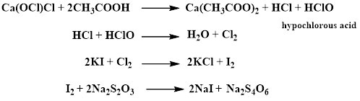

**Procedure**

* Accurately pipette 20 mL of the unknown solution into a conical flask.
* Dilute with 20 mL distilled water.
* Add 1 g of potassium iodide and 5 mL of dilute acetic acid respectively.
* Titrate the liberated iodine (brown) with 0.1 *N* sodium thiosulphate until getting a faint yellow colour.
* Dilute to 150 mL with distilled water and add 2 mL of starch solution to obtain a blue colour.
* Resume titration until getting a colourless end point.

**Calculations**

Each1 mL of 0.1 *N* Na2S2O3 is equivalent to 0.003545 g of available chlorine. This is calculated as follows:

$$1 mol.wt.of {Cl}_{2} ≡2 mol.wt.of {Na}_{2}S_{2}O_{3}$$

$$1 eq.wt.of {Cl}_{2} ≡1 eq.wt.of {Na}_{2}S_{2}O_{3}$$

$$\frac{70.9}{2} g of {Cl}_{2} ≡1 L of 1 N{Na}_{2}S_{2}O_{3}$$

$0.003545 g {Cl}_{2}≡1 mL of 0.1 N{Na}_{2}S_{2}O_{3}$

Correct the sod. thiosulfate volume=V’

V’ X ch. factor= gm of *available chlorine* in 10ml.

(gmX100) /10 = %w/v of *available chlorine.*

**The preparation and assay of aqueous iodine solution, Lugol’s solution**

* **Introduction**

Aqueous iodine solution, also called strong iodine solution or Lugol’s solution, is

a 5% w/v iodine in a 10% w/v potassium iodide aqueous solution.

Iodine is an essential trace element in the human diet, necessary for the formation of thyroid hormones, and consequently it is used in iodine deficiency and thyroid disorders. It also has antimicrobial activity. In the pre-operative management of hyperthyroidism.

* **Aim of the experiment**

Preparation 1000 mL of Lugol’s solution and determine the percentage w/v of both I2 and KI by titrating two portions of Lugol’s solution against *N*/10 sodium thiosulphate solution and *M*/20 potassium iodate solution respectively.

* **Chemical principle**

The free iodine content is determined by titration with *N*/10 sodium thiosulphate solution. The total iodine and potassium iodide is determined on another separate portion of the solution by acidification and titration with *M*/20 potassium iodate solution:

1. *Titration with sodium thiosulphate solution.*

Thiosulphate ions are oxidized directly by the iodine present in Lugol’s solution:



1. *Titration with potassium iodate solution.*

Potassium iodate is a powerful oxidising agent, but the course of the reaction is governed by the conditions under which it is employed. Under suitable conditions (degree of acidity) it reacts quantitatively with both iodine and potassium iodide.

The reaction between potassium iodate and iodide ions in solutions of moderate acidity (0.1- 2 *N* hydrochloric acid) stops at the stage when the iodate is reduced to iodine:



In the presence of more concentrated hydrochloric acid (3- 6 *N*) the iodine produced in the above equation is oxidized by iodate ions to the iodine cation, I+. The high concentration of chloride ions present in the medium leads to the formation of iodine monochloride, ICl, which is stabilized against hydrolysis by the hydrochloric acid present:



Thus, the complete reaction between KIO3 and KI in the presence of 3- 6 *N* HCl is expressed as follows by combining equations (2) and (3):



**Procedure**

1. Preparation of 1000 ml of strong iodine solution (Lugol’s solution).

The formula of Lugol’s solution is:

Iodine 50 g

Potassium iodide 100 g

Purified water qs. 1000 mL

* Dissolve the whole quantity of potassium iodide (100 g) in not more than 100 mL of water.
* To this concentrated solution add the whole quantity of iodine (50 g) and stir well until all the iodine has been dissolved.
* Then complete the volume with water to 1000 mL.
* Dilute 25 mL of this solution to 100 mL with water and this diluted solution will be used for the assay of both iodine and potassium iodide.

1. a) Assay of iodine.

* To 20 ml of the diluted solution add 10 ml of distilled water*.*
* Titrate with *N/*10 sodium thiosulphate until getting a faint yellow colour.
* Dilute to 150 mL with distilled water and add 2 mL of starch solution to obtain a blue colour.
* Resume titration until getting a colourless end point.
* Each ml of *N*/10 sodium thiosulphate is equivalent to 0.01269 g of iodine.

b) Assay of potassium iodide.

* To 10 ml of the diluted solution add 20 ml of distilled waterand 40 ml of concentrated hydrochloricacid.
* Titrate with *M/*20 potassium iodateuntil the dark brown solution which is produced becomes pale brown.
* Add 1 ml of amaranth solution and continue the titration until the red colour just changes to pale yellow.
* From the number of mL of *M/*20 potassium iodaterequired subtract one quarter of the number of mL of *N*/10 sodium thiosulphaterequired in the Assay for iodine.
* Each ml of the remainder is equivalent to 0.01660 g of KI.

**Discussion**

* *Calculations of the chemical factors*
* For iodine: From equation (1)

$$1 mol.wt.of I_{2} ≡2 mol.wt.of {Na}_{2}S_{2}O_{3}$$

$$1 eq.wt.of I_{2} ≡1 eq.wt.of {Na}_{2}S_{2}O_{3}$$

$$\frac{253.8}{2} g of I_{2} ≡1 L of 1 N{Na}_{2}S_{2}O_{3}$$

$0.01269 g I_{2}≡1 mL of 0.1 N{Na}_{2}S_{2}O_{3}$

* For potassium iodide: From equation (4)

$$2 mol.wt.of KI ≡1 mol.wt.of KIO_{3}$$

$$331.8 g of KI ≡1 L of 1 MKIO_{3}$$

$0.0166 g KI≡1 mL of M/20 KIO_{3}$

* *Calculations of the percentages of I2 and KI*

After correcting the consumed volume of sodium thiosulphate into 0.1 *N,* the weight and % (w/v) of iodine in the sample are to be calculated. Just multiply the corrected volume by the chemical factor to obtain weight %w/v of iodine in the sample assayed.

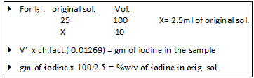

V’ the corrected volume of sod. thiosulfate.

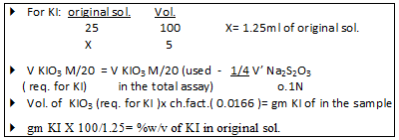

*VKI* can be multiplied by the chemical factor without correction since potassium iodate solution is prepared without standardization because it is obtained in a high degree of purity so only accurate weighing and volume adjustment are needed .

***Potassium iodate as a standard solution***

Because potassium iodate can be obtained in a high degree of purity (99.9%) a standard solution of potassium iodate can be prepared without the need for standardization provided that weighing and volume measurements are accurate. The concentration of this standard solution is expressed in terms of molarity rather than the usually used normality. This is because potassium iodate solution is often used in the titrations of solutions containing both iodine and iodide ions and the number of electrons transferred in its reaction with iodine is different from that with iodide. Therefore molarity is used to avoid confusion.

* *Stability of iodine monochloride*

The iodine monochloride produced during assay of potassium iodide is stabilized and prevented from hydrolysis back to iodine, thereby preventing continuous or endless titration with potassium iodate, by the action of the high acidity used and, hence, by the high chloride ion concentration present in the medium through the formation of a stable complex ion with chloride ion:



* *End point detection*

Starch is used to detect the end point of iodine titration with sodium thiosulphate in the usual manner. However, due to the high acidity used in titration with potassium iodate starch cannot be used because the characteristic blue colour of the starch-iodine complex is not formed at this high acidity.

So starch is replaced by certain dyes which act as internal indicator, e.g. amaranth (colour changes from red to pale yellow). This indicator is added near the end point. It is stable in the presence of iodine, iodine monochloride, and strong hydrochloric acid but is destroyed only by the first slight excess of iodate.

**Assay of Magnesium Sulfate**

It is also called Epsom salt (heptahydrate) or English salt.( MgSO4.7H2O,M wt. = 246.5 gm/mole) its contain not less than 99.5% MgSO4 calculated with reference of dried substance. It is colorless crystal, or white crystal powder.

It is soluble at 20˚C in 1.5 parts of water, sparingly soluble in alcohol 96% i.e. practically insoluble in 96% ethanol.It is used as laxative agent.

* **Aim of the experiment**

Determination of the percent of magnesium sulfate in an unknown sample.

* **Procedure**
* To 10 ml of the unknown solution add 10 ml of buffer solution.
* Add 0.1gm mordant black indicator
* Titrate with M/20 EDTA until the colour change from pink to blue or bluish violet.
* Each ml of M/20 EDTA≡0.012325gm MgSO4.7H2O.
* **Chemical principle**
* The technique involves titrating *metal ions* with a *complexing agent* or *chelating agent (Ligand)* and is commonly referred to as ***complexometric titration***.This method represents the analytical application of a complexation reaction. In this type of titration we use ***metal ion indicator.***
* Magnesium ions form relatively weak complex with (EDTA; Ethylenediamine-tetraacetic acid).



* The stability of metal complex is pH dependent. Lower the pH of the solution, lesser would be the stability of complex (because more H+ ions are available to compete with the metal ions for ligand). But at pH 10 the reaction is rapid and quantitative.
* NH3- NH4Cl buffer is used to maintain this pH.
* EDTA which is polyamine carboxylic acid is one of the most frequently used chelating agent:

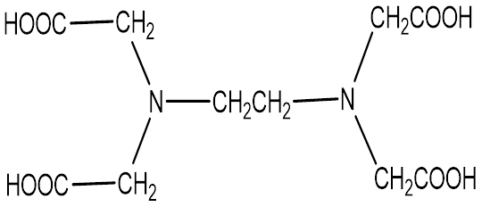

* EDTA form soluble, stable 1:1 chelates with metal ion. Because of the low water solubility of the free acid form of EDTA, the disodium salt (Disodium EDTA ) is used in preparation of std. sol.
* Metal indicators are used to detect the end point in complexometric titration. They are dyes which produce one color in the presence of metal ions and a different color when they are absent.

The color changes are the result of displacement of the H⁺ ions by the metal. The metal indicator form 1:1 complex (MI) which must be weaker than the Metal-EDTA complex.

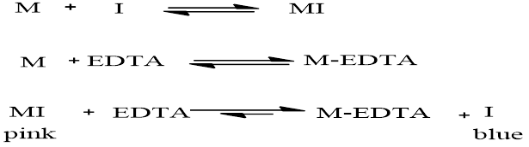

Finally, at the equivalent point, EDTA removes the last traces of metal ions from its colored complex with ind.(MI) to free metal (I) of another color.

Mordant black indicator**:** it has blue color at pH 10 and most of its complexes are reddish.

***Note:***

In pH less than *6.3* and more than *11.5*, the indicator and its complexes are reddish, so it is necessary to carry out the titration in the presence of ***buffer at pH 10***.

**Calculation:**

V X ch. factor= gm wt. of MgSO4.7H2O

wt X 100/10= %w/v of unknown.

**Salicylates**

Salicylates are group of organic comp. which are used for their physiological and biological activity.

The parent comp.is salicylic acid .it has a strong antiseptic and germicidal properties that is why it is used as a preservative for foods and pharmaceuticals , had good escharotics, for treatment of warts ,corns and athlets feet (externally), internally (seldomely used), although it shows antiseptic &analgesic activities ,its salts and other derivatives are used for these purposes.Two types of salicylic acid derivatives are present:

1-esters of carboxylic acid . 2- usually substitution of the phenolic group.



Most of these derivatives have been introduced to decrease the gastric disturbances ,hemorrhage ,irritation and undesirable taste.

* H.W: why carboxyl group is more acidic than phenolic group in salicylic acid?

Although some P- isomer is formed but ortho isomer is more likely to form why? And separation can be done by steam di stillation since ortho isomer being more volatile .

**preparation of ASA by using acyl chloride**

Aspirin was prepared from the reaction of salicylic acid and acetic anhydride. Phosphoric acid was used as a catalyst. Upon addition of cold water, acetic acid was formed and thus eliminated. Other impurities like salicylic acid were removed upon the process of recrystallization.

The melting point range of the purified and crude samples were compared to the literature value and it showed that the purified sample is logically “near” to the literature value because of its narrow range.The recrystallized product was differentiated from commercial aspirin through iodine test and it showed that the commercial aspirin contains starch. Other tests such as water solubility test, FeCl3 Test, KMnO4 Test and Tollen’s Test differentiated aspirin from starting materials.

* acetylation of salicylic acid by using acetic anhydride

* very reactive acetylating agent *the reaction is vigorous and not safe

*the rate of reaction is faster than that of acetic anhydride

*it produce corrosive HCL gas so pyridine should be used as a base to pick up the proton and give pyridinium chloride

* Rate of acetylating agents arrangement is :

> Acetic acid Acyl chloride > acetic anhydride

The best one is acetic anhydride.

1 mole of S.A = 1 mole of ASA

Wt /m.wt S.A = wt/m.wt ASA

2.5gm /138 =wt /180

Wt = 3.25 gm ASA theoretically

% yield = wt practically / wt theoretically *100

% yield = 2.5 gm (for example) /3.25 *100 = 85%

* Notes:

* we should used dry coinical flask,why? *temp. should be between 55-60 °c ?

*ASA is hydrolysed by boiling with dilute alkali to give sod. Salicylate and sod .acetate.

*ASA itself is sufficiently acidic to produce effervescent with carbonate.

* Acetic anhydride is used chiefly to make esters that cannot be made by direct esterfication with acetic acid ,its cheap ,readily available ,easily handled and forming corrosive HCL with moderate activity (the reaction is safe).

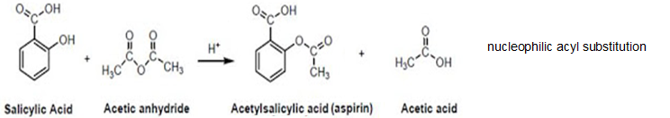

**Sulfonamides**

They are mostly antibacterial agents ,act as bacteriostatic that stops the growth of bacteria by competition with PABA needed by bacteria to synthesize its folic acid, so sulfa drug is metabolite antagonist.Sulfonamides are derivatives of para amino benzene sulfonamide

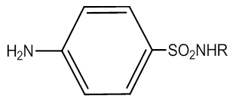

* sulfonamides derived from primary amines have an acidic hydrogen and dissolve in alkali but precipitate out when the mixture is acidified.
* Sulfonamides derived from secondary amines are insoluble in alkali and appear as precipitate which persist upon acidification of the mixture.
* When aniline is shaken with bromine water ,2,4,6-tribromo aniline is yield as a white ppt.

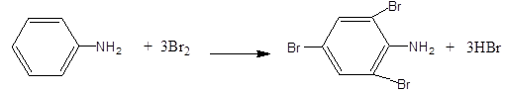

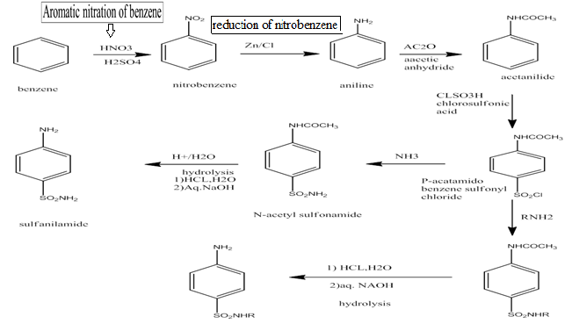

Scheme of sulfa drug

**Preparation of paracetamol (P-acetamido phenol)**

Acetaminophen or acetaminophen is a *P*- acetamido phenol or it is N-acetyl P-aminophenol or 4-hydroxy acetanilide.

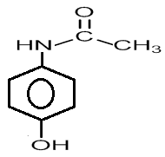

Paracetamol is a very widely used analgesic and antipyretic. It is a relatively safe drug though toxicity has been observed with very high doses.

* ***Preparation:***

It may prepared by reduction of P-nitrophenol in glacial acetic acid . acetylation of P-nitrophenol by using acetic anhydride.

Their characteristic reactions are with nucleophilic reagents, acetic anhydride reacts with compound containing active hydrogen atom to form derivatives containing acetyl group.

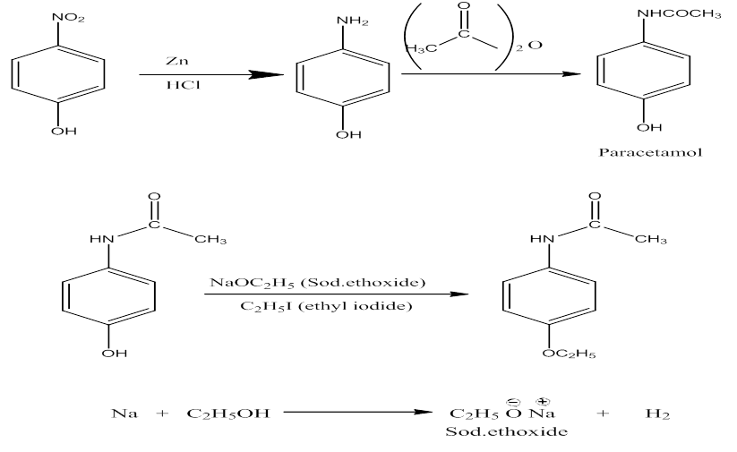

Though –NH2 is more nucleophilic than –OH, excess Ac2O should be avoided as there is chance of double acetylation of 4- aminophenol.

**Spectrophotometric Analysis**

Spectrophotometric techniques are used to measure the concentration of solutes in solution by measuring the amount of light that is absorbed by the solution in a cuvette placed in the spectrophotometer. Spectrophotometry takes advantage of the dual nature of light. Namely, light has:

1. a particle nature which gives rise to the photoelectric effect

2. a wave nature which gives rise to the visible spectrum of light

Atoms and molecules posses the ability for energy absorption which is in form of electromagnetic radiation . The type and quantity of the absorbed energy by the molecules depend on the chemical structure of these molecules , in addition to that ,the quantity of absorbed energy depends on the number of the raacted molecules withthis radiation .

Electromagnetic radiation is a term applied to the diffused energy in form of wave The electromagnetic spectrum is composed of wide range of radiation frequencies .It is possible to divide the spectrum into the following regions according to the wavelength, energy , and the nature of interaction between the molecules and radiation :-

|  |  |  |  |
| --- | --- | --- | --- |
| No | Radiation | No | Radiation |
| 1 | Cosmic rays | 5 | Visible rays |
| 2 | γ-rays | 6 | IR-rays |
| 3 | X- rays | 7 | Micro waves |
| 4 | UV-rays | 8 | Radio waves |

In a spectrophotometer, a light source gives off white light which strikes a prism, separating the light into its component wavelengths (Figure 2.). Thus, lightwaves can be separated by frequency.

For the visible waves The visible spectrum ( 400 – 750 nm ) extends from the spectrum near to the IR to the spectrum near to the UV as in The following table :-

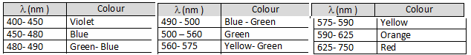

**BEER'S LAW**

When monochromatic light (light of a specific wavelength) passes through a solution there is a quantitative relationship between the solute concentration and the intensity of the transmitted light.The amount of light absorbed by the a medium ( solution/ sample) is proportional to the concentration of the absorbing material or solute present. Thus the concentration of a coloured solute in a solution may be determined in the lab by measuring the ABSORBANCY OF LIGHT AT A GIVEN WAVELENGTH

* **LAMBERT'S LAW**
* . described how intensity changes with distance in an absorbing medium.
* . The amount of light absorbed by the a medium ( solution/ sample) at a given wavelength is proportional to thickness of the absorbing layer: path length of the light.
* **BEER – LAMBERT LAW**

It states that the absorbance of light by a material in a solution is directly proportional to its concentration in that solution.

***A* = *ϵlc*** Where, A – absorbance ***ϵ*** - molar absorptivity

l – length of solution c – concentration

* **Transmittance**

Defined as the ratio of the intensity of light emerging from the solution (I) to that of incident light entering (Io)

The ABSORPTION COEFFICIENT: (α ) = Molar absorptivity (extinction coefficient) of the absorber, (c) X the concentration (c) of absorbing species in the material

The fraction of the incident light absorbed by a solution at a given wavelength is related to : a. thickness of the absorbing layer (path length)

b. concentration of the absorbing species.

* **THE COMBINED LAMBERT’S LAW AND BEER’S LAW**

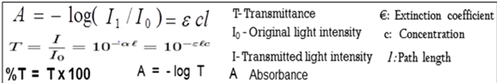



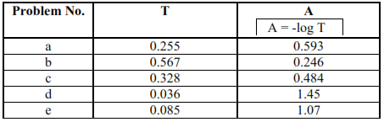

A solution containing 4.48 ppm KMnO, had a % transmittance of 30.9% in a

1.00 cm cell at 520 nm. Calculate the molar ahsorptivity of KMnO, at 520 nm.



A = εbc

mmol KMnO4/mL =(4.48 mg /1000 mL) x (mmol /158 mg) = 2.84x10-5 M

T = 0.309

A = - log T = - log 0.309 = 0.510

0.510 = ε * 1.00 cm * 2.84x10-5 mol/L

ε = 1.80x104 L mol-1 cm-1

* we prefer to express the Beer-Lambert law using absorbance as a measure of the absorption rather than %T because:

A= ε bc %T = 100 I / I0 = e - ε bc

Now, suppose we have a solution of copper sulphate (which appears blue because it has an absorption maximum at 600 nm). We look at the way in which the intensity of the light (radiant power) changes as it passes through the solution in a 1 cm cuvette. We will look at the reduction every 0.2 cm as shown in the diagram below. **The Law says that the fraction of the light absorbed by each layer of solution is the same.** we will suppose that this fraction is 0.5 for each 0.2 cm "layer" and calculate the following data:

