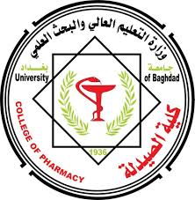

College Of Pharmacy / University of Baghdad
Department of Clinical Pharmacy- Department of Pharmaceutics

Pharmacy Student Summer Practice Guide:
Navigating Your Path to Success
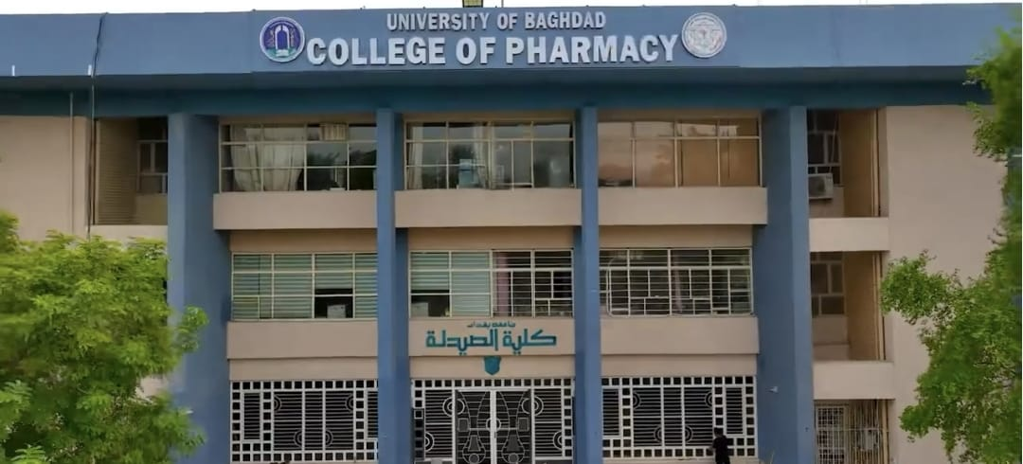

Prepared By:
Professor Dr Mowafaq Mohammed Ghareeb…. Assistant. professor. Dr. Samer Imad Mohammed
Assistant professor Dr Lubna Abdalkarim Sabri …. Assistant professor Dr Omer Saeb Salih
Assistant. lecturer. Ahmed Majid Hameed … Assistant. lecturer. Angham Ahmed

Chapter 1: Introduction
Section 1: Overview of the pharmacy profession
Section 2: Role of pharmacists in healthcare
Chapter 2: Training requirements
Section 1: Criteria for Community Pharmacies Used in Pharmacy Student Training
Section 2: Training Manual
Chapter 3: Training Guide for Pharmacy Student Trainers

Chapter 4: Dosage Forms concerns Pharmaceutics department

Dear College of Pharmacy-University of Baghdad students, the summer training committee will send you the entire material to your official email address when you begin your summer training course.

